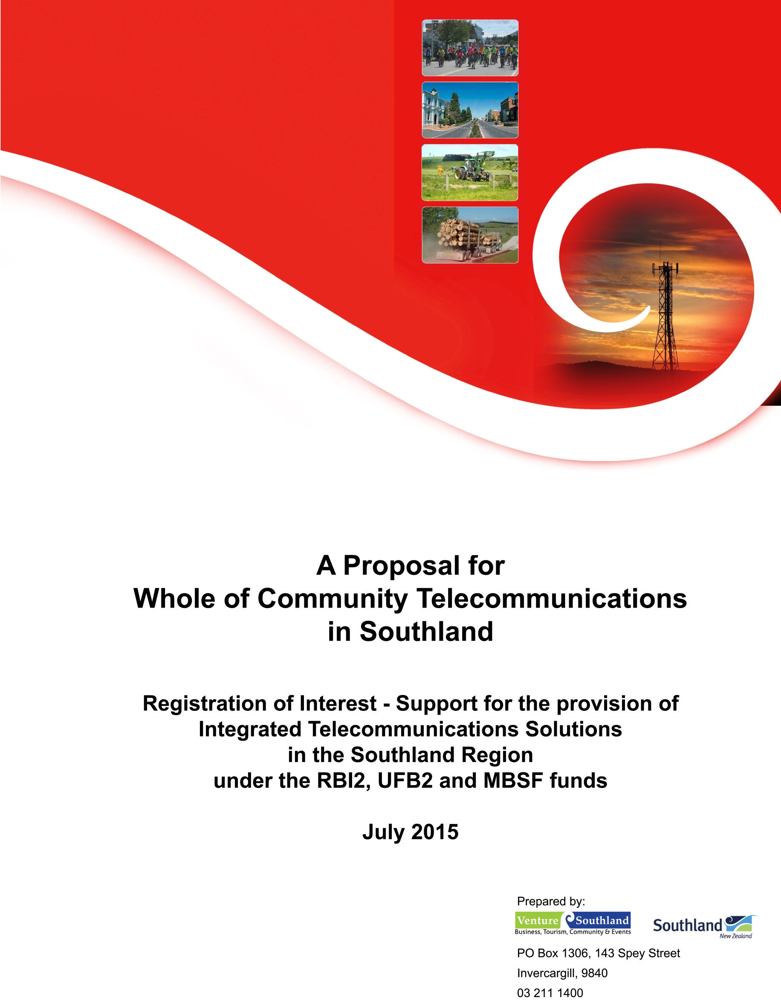

Venture Southland
PO Box 1306
143 Spey Street
Invercargill 9840

Tel. +64 3 211 1410
robin@venturesouthland.co.nz
www.southlandnz.com



8 July 2015

File: 940/15/4/1

A Proposal for Whole of Community Telecommunications in Southland:
Registration of Interest- Support, for the Provision of Integrated Telecommunications Solutions in the Southland Region under the RBI2, UFB2 and MBSF funds

Contents

1. Executive Summary 4
2. Southland 6
3. A strategic telecommunications future for Southland 8
4. RBI, UFB and MBSF and other initiatives 10
4.1. Mobile telephony-data convergence 14
4.2. Improvised wireless technologies 15
4.3. Spectrum management 15
4.4. Mobile roaming 15
4.5. Mobile network performance 16
5. Telecommunications Technology Roadmap 17
6. Proposed Southland Pilot Project 21
Appendix 1. Metcalfe’s Law and Southland 23
Appendix 2. Local Loop transmission limits 25
Appendix 3. Some estimates of the cost to deploy high speed broadband in rural Southland 26
Appendix 4. Digital Dividend 30
Appendix 5. Some observations on Telecommunications Infrastructure 31
Appendix 6. Southland Region Broadband Review 33
Appendix 7. Southland Mobile and Internet Survey 2015 50
Appendix 8. New Zealand Engineering Excellence Awards 2005 89

A Proposal for Whole of Community Telecommunications in Southland:
Registration of Interest- Support, for the Provision of Integrated Telecommunications Solutions in the Southland Region under the RBI2, UFB2 and MBSF funds

THIS IS AN ALTERNATIVE REGISTRATION OF INTEREST AND SHOULD BE CONSIDERED SUBSERVIENT TO VENTURE SOUTHLAND’S COMPLIANT REGISTRATION OF INTEREST THAT HAS BEEN LODGED SEPARATELY.

Executive Summary
This proposal strongly recommends a locally managed core telecommunications network investment and programme, focused on the enduring and future-proofed components of those networks. To this end, Southland stakeholders, through Venture Southland, propose the establishment of a pilot programme to deliver an integrated approach to deploying universal and affordable broadband and cellular telecommunications throughout rural Southland with long term benefits. This proposal is consistent with the Southland Digital Strategy.
Efforts to modernise New Zealand’s telecommunications networks have so far been successful in the cities and largest towns where UFB and commercial fibre-optic cable access will soon be available to all, and 3G – and soon 4G - mobile cellular coverage is nearly complete. The same cannot be said for rural New Zealand, where RBI and private sector investment has, with few exceptions, been successful only in providing fibre-optic cable access to schools and, in Southland, unhelpfully overbuilding an existing 3G broadband wireless network.
The RBI investment has not proven to be useful in Southland primarily because there is no long-term, agreed goal for broadband and cellular service in rural New Zealand. Accordingly, there is no agreed technology roadmap and as a direct consequence it has not been possible to identify the best strategic investment decisions, nor to determine a long term budget commitment.
It is considered that the current separate investment models for UFB, RBI and MBSF are fundamentally flawed as they do not provide an integrated solution with a strategic investment pathway. Despite good intentions, these initiatives have not harnessed local expertise and knowledge to best advantage. At worst, they have seriously undermined existing investment in telecommunications infrastructure, as is now explained.
In Southland, the first round of RBI funding only served to overbuild the Woosh Wireless network that had been completed in 2007 under the Southland Whole of Community Broadband initiative. The Woosh Wireless network provided affordable 3G coverage, allowing some 95% of Southland dwellings to have 1Mbps or better Internet access. As a result of the RBI contract being awarded to subsidise Chorus and, in particular, Vodafone’s network expansion, the business case for the planned upgrade of Woosh Wireless’ 3G technology to 4G was completely undermined, leaving a $10M investment by ratepayers, government and private enterprise stranded. Worse, the RBI produced no tangible improvement in broadband service in Southland: a survey with 95% confidence level found that Southlanders could identify no real improvement in their broadband service over the last five years. Analysis of the Vodafone – MBIE RBI contract reveals an absence of meaningful technical metrics for network performance, allowing no contractual remedy to improve the situation.
Venture Southland has had some difficulty in preparing a conforming Registration of Interest for the RBI2, UFB2 and MBSF initiatives as these initiatives ignore voice and data convergence, and the need to establish network architecture that delivers enduring benefits and a robust forward digital pathway at a time when demands for greater bandwidth is rapidly accelerating.
Any forward planning by telcos has had to be second-guessed. It has also been difficult identifying coverage black-spots as it has become apparent that stated wireless RBI performance is overly optimistic and claimed wireless and cellular coverage in many cases is not supported by field testing.
If Southland is to remain an economic powerhouse of New Zealand, fibre-optic broadband access to every farm and dwelling in Southland is required and, simultaneously, ubiquitous LTE mobile telephony and Internet access. An annual network investment of between $5.5M to $7.7M over the next 15 years is required to build the networks to provide such service.
Venture Southland proposes a pilot programme to deliver an integrated solution that will deliver marked improvement to Southland broadband and cellphone access through an innovative application of the RBI, UFB and MBSF funding allocations due to Southland. In essence, it is proposed that Venture Southland act as a bulk funder to manage a roll-out of terrestrial Internet and cellular services in the region.
This proposal requires:
- Commitment to the dual objectives of ‘Fibre Everywhere’ and ‘LTE Everywhere’ at an affordable price to customers,
- Agreement that a 15 year staged strategic approach is necessary for telecommunications network investment in New Zealand,
- That Venture Southland work in partnership with MBIE and telecommunications network providers to develop an agreed, fully-costed, and integrated technology roadmap,
- That Venture Southland work in partnership with MBIE and telecommunications network providers to award funds to UFB2, RBI2 and MBSF projects in Southland, and oversee their deployment and acceptance testing,
- That the Telecommunication Development Levy is substantially increased, recognising that low-cost urban customers have a duty and reciprocal interest to ensure that more expensive rural customer connections are provided,
- The Telecommunications Development Levy and Government contributions to RBI and UFB awarded to Southland must encourage a network investment of at least $6M per year, particularly in light of the age of the existing copper network,
- All mobile cellular operators to provide mandatory no-surcharge roaming across their competitors’ networks where their own network does not provide good coverage,
- That the delivery of service in Southland be overseen by a local statutory entity and governance group responsible for the oversight of deployment programmes, establishing priorities and providing local accountability,
- That priority be given towards co-investment into the enduring elements of the networks such as towers and fibre-optic deployment as these are effectively 50 years assets and provide long term benefits to local communities,
- That tenders be let regionally for delivery of the services specified.
There is some real urgency in adopting this proposal: the existing underground copper telecommunications network in Southland is starting to reach the end of its design life and given the timescale available to deploy its replacement, work needs to be embarked upon in the near future.
The areas Venture Southland has identified for immediate network augmentation are identified in Venture Southland’s complying RoI under the UFB2, RBI2 and MBSF initiative.

Southland
Southland is a geographically diverse region, encompassing 12% of New Zealand’s landmass. With 2.4% of the population, Southland Industry produces 15% of New Zealand’s tradable exports. The region’s productive capacity rests on the land and value-added production; farmers and other rural businesses need access to fast and reliable internet and mobile services in order to continue to grow productivity and retain competitiveness within a fast changing global economy.
In 20013-2014 Southland’s economy grew by 11%, the highest rise in GDP within New Zealand, representing an addition of $550 million to the local economy and cementing its position as a leading export region. Southland has the highest employment and participation rates in the country and an aging workforce. To retain our young people and attract skilled workers to Southland, connectivity to global culture, and family and friends around the world is essential.
Venture Southland, in its role of promoting economic and community development for the Southland region, has prepared this Registration of Interest on behalf of Southland District Council, Invercargill City Council and Gore District Council.
Venture Southland has been involved in telecommunications work since the design of the Whole of Community Broadband initiative in 2000 which led to the rollout of 32 transmission towers across the region as part of a public-private partnership. This provided a lifeline to rural residents and business people giving them access to what was at the time leading edge technology. However as data demands have grown the existing options are no longer serving the needs of the community.
In preparing the ROI we have consulted widely with the local community:
- The three Territorial Local Authorities through Mayoral forums, Shared Services, Emergency Management and Venture Southland’s Joint Committee
- Consultation with local communities at proposed sites through Venture Southland’s Community Team. Letters of support are included within the supporting documentation for each site
- The Southland Mobile and Internet Survey 2015 which was open to all residents of Southland. 720 businesses and residents responses were analysed and informed the bid. Many of their comments are included within the supporting documentation
- Over 80 businesses were consulted at a Digital Enablement Workshop organised by Venture Southland in partnership with NZTE.
We have also drawn on the technical knowledge that Venture Southland has developed through managing a range of other contracts and projects in the communications sector, including the initial scoping and design for the Invercargill Urban Fibre Network and the management of contracts with the European Space Agency, French Space Agency, Planet Labs, SpaceFlight and Rocket Lab for space vehicle launches and operations from the Awarua Satellite Ground Station.
Further technical expertise has been contracted from Tony van Horik of Advanced Technology Solutions Ltd who undertook a review of Southland’s current broadband infrastructure. His findings reinforce the feedback we have had from residents in many rural areas who are reporting that RBI1 has had significant limitations.
Mapping of the mobile cellular service coverage on Southland’s State Highways for both the Vodafone and Spark networks was undertaken on Venture Southland’s behalf by Opus International Consultants. This data reveals many coverage blackspots and poor signal areas.
The research we have undertaken and commissioned as part of the preparation for this RoI has given a much clearer picture of the state of services across the region.
Venture Southland’s long commitment to the promotion of world standard telecommunications services for the region is reflected in the 2008 Digital Strategy, which was prepared for the region. This strategy is currently being reviewed and updated and will be submitted as part of this RoI process by the September deadline.
In its role as NZTE and Callaghan Innovation Regional Business Partner, Venture Southland has been supporting businesses with their challenges in connecting to fibre and have organised training events to help up-skill businesses in the latest use of cloud, apps and other online software. This work dovetails with our successful business efficiency, productivity and skill development programmes which are highly dependent on businesses being able to take advantage of the opportunities presented by world class telecommunications technology. All three TLAs and Venture Southland are committed to continuing to raise awareness of the benefits of broadband to encourage both uptake of new service offerings and how to maximise the benefits these services offer to communities and businesses.

A strategic telecommunications future for Southland
The strategic need for universal high speed, reliable broadband is universally recognised in Southland: the effort directed to UFB and UFB2 amply demonstrate the necessity of providing fibre-optic connectivity to all Southland dwellings and the same arguments hold that justify providing rural users with the same bandwidths. Indeed, Metcalfe’s Law establishes categorically the importance of providing ubiquitous telecommunications throughout the region (see Appendix 1, which also addresses the work of Melody in network utility cost benefits, and applies to a Southland setting).
In 2008 Venture Southland prepared the Southland Digital Strategy, which reaffirmed the goals developed by Venture Southland for telecommunications in 2001:
“Southland is an excellent place to live, learn and do business, enabled by a world class, affordable telecommunications network which serves the whole of our community”.
The 2008 Southland Digital Strategy is strongly of the view that telecommunications network providers must upgrade and augment their networks in Southland to ensure all of our community can enjoy world-class telecommunications services. To this end, strong advocacy, assistance and possible political intervention was called for to:
- Prompt Telecom New Zealand’s cabinetisation programme to include more than the [then] planned 75% of Southland dwellings,
- Strongly encourage all cellphone service providers to upgrade their Southland networks with alacrity to 3G, or later technology and extend their coverage to include the presently poorly served rural sector.
Earlier this year, a start was made in updating the Southland Digital Strategy and preliminary analysis confirmed that there had been useful work done in this area. However, since 2008, the telecommunications technology landscape in New Zealand has matured and a new analysis of Southland’s telecommunications future and technology developments concludes that a long term strategy is required to achieve:
- Fibre Everywhere: all dwellings in Southland – both rural and urban – shall be provided with fibre-optic Internet access,
- LTE Everywhere: all inhabited parts of Southland, including farms, shall have 4G LTE mobile cellular service or better.
The reasoning for adopting these goals is presented later in this proposal. A more challenging question is to ask if these are realistic goals. We believe that they are:
There are some 17,300 farms and dwellings in rural Southland. Our estimates place the cost of deploying fibre-optic cable to every farm and dwelling in Southland at between $75M and $112M, or between $4,335 and $6,475 per customer. While these figures do need to be rigorously verified, we can be confident that they are not far off the mark. In adition, the cost to provide LTE service to all of Southland would cost in the order of $22M, or $1,271 per household (See Appendix 3).
This is clearly not within the capacity of any short term funding budgets, but as the work would need to be undertaken over, perhaps, 10 to 15 years in practical terms, this establishes a capital budget of $5.5M to $7.7M per year. This is possible with the present Southland workforce.
It is recognised that the magnitude of these costs may initially seem daunting; however, it should also be recognised that both the fibre-optic cable deployment for customer reticulation and back-haul connectivity are long term infrastructural assets: fibre-optic cables should have at least a 50 year economic life and hill-top masts and towers have in excess of 50 years lives. These key pieces of infrastructure also provide enduring pathways for other technologies to provide performance enhancement, such as current and future versions of wavelength division multiplexing, and as platforms for improved wireless and mobile technologies. Venture Southland is strongly of the view that as a first priority, network capital co-investment should be directed at these core elements.
To this end, it is proposed to establish a pilot programme to deliver an integrated telecommunications solution that will deliver marked improvement to Southland broadband and cellphone access through an innovative application of RBI, UFB and MBSF allocations due to Southland.
Venture Southland would act as a bulk funder to manage a 15 year staged roll-out of terrestrial Internet and cellular services in the region, working in partnership with MBIE and telecommunications network providers. The initial work would be focussed on developing an agreed, fully-costed, and integrated technology roadmap in partnership with MBIE and telecommunications network providers with a view to awarding UFB2, RBI2 and MBSF funds in Southland for projects that support the roadmap. Venture Southland would then oversee the resulting network deployment and acceptance testing.
The delivery of this service would in turn be overseen by a local statutory entity and governance group responsible for the oversight of deployment programmes. This group would also be involved in establishing priorities and providing local accountability, and then letting tenders for delivery of the services specified. This model worked extremely well for the Southland Whole of Community Broadband project between 2002 and 2007 (See Appendix 8).
Priority must be given towards co-investment into the enduring elements of the networks such as towers and fibre-optic deployment as these are assets will provide long term benefits to local communities. Venture Southland’s compliant RoI under UFB2, RBI2 and MBSF provide a strong basis on which to base immediate network expansion.
The serious risk if such an approach is not taken is that three, as opposed to the current two, digital divides will form in New Zealand: those without affordable terrestrial Internet service of any speed; those who have low-speed and unreliable first-generation broadband that is unable to support converging voice, video and data services; and those who have low-cost, high speed fibre-optic based broadband in the cities and large town. Noting that even the capital investment described above is only realistically achievable over a 10 to 15 year period, postponing a concerted effort to invest in infrastructure will create a serious service shortfall in the medium to long term future.
The other risk if a strategic investment position is not adopted is that in five to ten years the technologies that do not fit into the technology roadmap will need complete replacement and the present investment abandoned.

RBI, UFB and MBSF and other initiatives
The asymmetry of the RBI2, UFB2 and MBSF initiatives are extraordinary: Central Government initiatives in essence require Local Government at its own expense to help shore up the telecommunications industry’s capital investment shortfall that has occurred over many years and fill in for the local knowledge that has been abandoned through continual centralisation of the telcos’ planning teams and project administration effort.
What is worse is that RBI1 managed to side-line the one major broadband network provider in Southland who had shown the region loyalty and initiative by funding an over-build of the Woosh Wireless network that had been paid for by private, ratepayer and Government funds. In large part, the Vodafone network in Southland that was funded through RBI1 only served to duplicate the Woosh Wireless network coverage and improve access speeds by less than a factor of three. It is not surprising, then, that Woosh Wireless has chosen not to directly participate in RBI2. Even the expansion of the Vodafone network to provide wider coverage under RBI is questionable noting that the Woosh Wireless Waikia site – a major investment that cost Woosh Wireless in the order of $250,000 to build – was sold to Vodafone for use as an RBI site.
The performance of the RBI and UFB initiatives in Southland is discussed in detail in Appendices 6 and 7. The survey conducted earlier this year by Venture Southland of broadband and mobile customers lead to some disappointing and concerning conclusions, indicating some serious deficiencies.
It is useful to highlight both the ad hoc and planned network investment in Southland over the last twelve years and the following summary of network developments highlights this:
- Woosh Wireless 3G service has provided 1Mbps broadband access to nearly 90% of Southland since 2007
- Vodafone has been overbuilding the Woosh Wireless coverage area with RBI funding on the 700MHz and 2100MHz bands with 3G and more recently LTE equipment
- Vodafone has been building out a 3G network on 900MHz for mobiles only
- Spark has been deploying its own mobile cellular service
- Spark has announced that it will deploy a 700MHz point-to-multipoint fixed Internet service, which will overlay both the Vodafone and Woosh networks
- PowerNet deployed a fibre-optic cable network in 2010, including a suburban FTTH trial
- Chorus has been laying fibre in Invercargill under UFB1
- Chorus has laid fibre in earlier times in the Invercargill CBD, to businesses and cabinets
- Chorus has completed its cabinetisation programme in Invercargill, providing fibre to the cabinet.
- Chorus has laid a very limited number of fibre-optic cables in rural Southland under RBI.
- Chorus has deployed a number of rural DSL cabinets in rural Southland, mostly under RBI.
- Yrless, Velocity Net and Areneo have been deploying small-scale Wi-Fi networks
What is missing is an accurate and easily assimilated overview of the actual telecommunications services now available in Southland and how to best harness them. The net result in Southland is that it is very confusing for potential customers to identify service providers and understand what level of service is available to them. Examination of coverage maps show that a lot of network build-out by the competing telcos to a large extent provides duplication rather than improved or extended service. The overlap of the competing networks’ coverage becomes apparent from studying the coverage maps below.
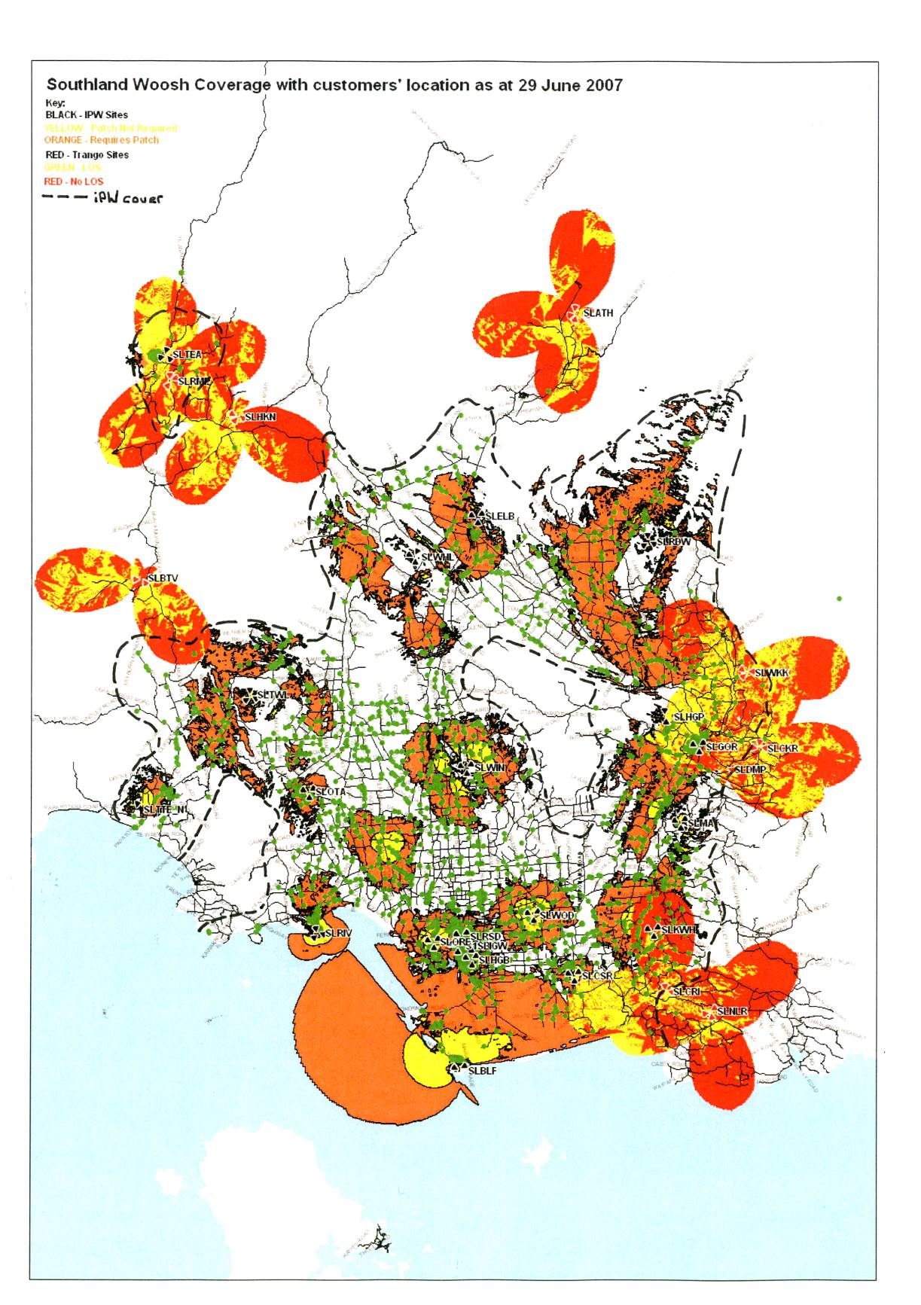
Woosh Wireless coverage map as at 29th June 2007. Combined with Telecom’s ADSL technology, between 93% and 97% of Southland dwellings could access 1Mbps or better broadband at competitive prices. The green dots represent Woosh Wireless wireless customers. Note that actual coverage exceeds the predicted coverage areas. (after Woosh Wireless in-house coverage map).

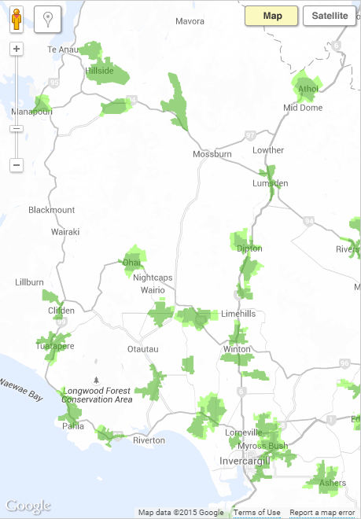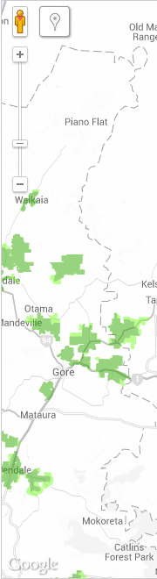
Chorus RBI DSL service. It is not clear what the selection criteria may be. (Sourced from Chorus website)
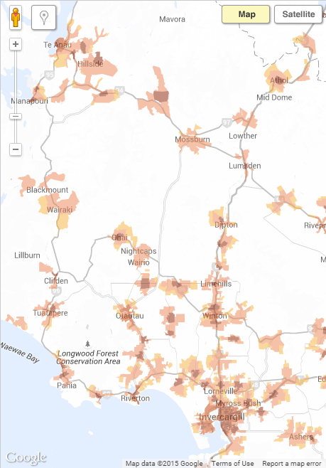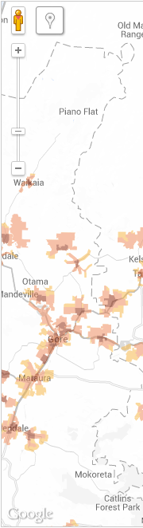
Chorus DSL service. (Sourced from Chorus website).

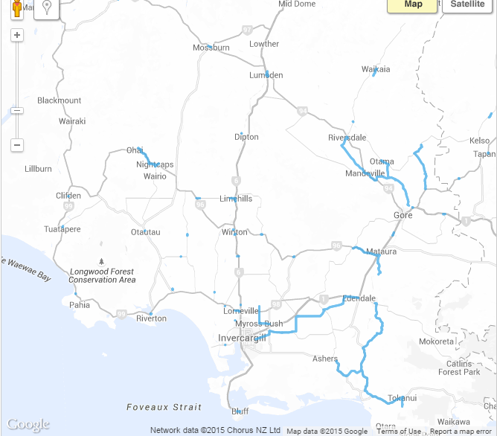
Chorus RBI1 fibre-optic map. Note that the only major cabling has been the Invercargill-Edendale-Tokanui and Gore-Riversdale routes. The other routes have been between schools and their local exchanges. (Sourced from Chorus website)

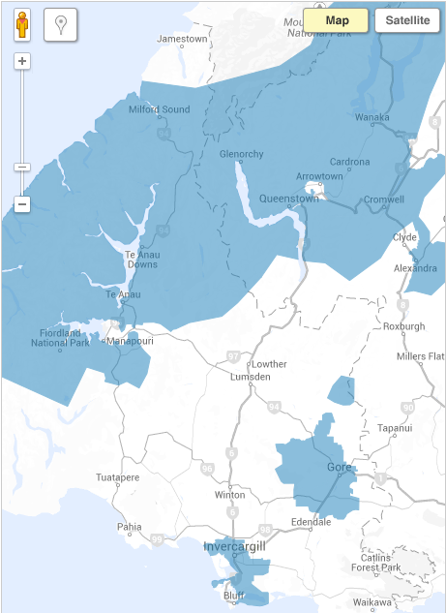
Chorus Business fibre coverage area. One wonders if Chorus is indeed able to provide fibre-optic service into half of Fiordland and all the Snowdon Forest. (Sourced from Chorus website).
It is often overlooked that New Zealand’s remarkably diverse geography must be served by an equally diverse infrastructure; a long, skinny telecommunications network design that suits the West Coast does not match the Southland Plains, for example. Regional planning can more easily take advantage of and be attuned to geographic features, population trends and such like than centralised planning.
The new RBI and UFB initiatives will struggle to be effective unless Local Government – in this case represented by Venture Southland – is empowered to provide local input and oversee infrastructure deployment in a coherent and strategic fashion. Importantly, Local Government must be involved in the selection process and prioritising of network infrastructure carried out under these initiatives in partnership – not as a bidder to, or at a distance from – MBIE.
In addition, Local Government needs to be resourced to ground-truth the performance of the network deployments at both the commissioning and subsequent operation stages. While many councils simply do not have the resources to undertake such work – and neither do MBIE, nor the telcos, it would so appear – Venture Southland has a proud track record in the design, advocacy, accountability and governance capability to make a positive contribution towards establishing good telecommunications in the region (See Appendix 8). Venture Southland is well connected to the Southland community and has as good understanding of the technical issues and how they affect the community.
One advantage that smaller regions, such as Southland, have over large cities is that the consequentially smaller networks can be understood by a small team. For example, just the feeder network of Auckland is more complicated than the entire Southland reticulation network; Vector estimated that to design its proposed Auckland UFB network would require 50 man-years of effort, yet it is possible for just a few people to comprehend the entire Southland network in some detail and a small team with a local office to plan it.
This proposal deliberately does not address UFB deployments. As an aside, all is not well with UFB in Invercargill though that need not concern us here. It is nonetheless salutary to note that the PowerNet Fibre To The Home trial three years ago was able to deliver results somewhat cheaper, and to our minds better, than the Chorus deployment. In addition, the price of equivalent services to Southland Girls’ High School and University of Otago’s teachers college for unsubsidised PowerNet fibre would rise from $600/month to $1,500/month and $2,400/month respectively.

Mobile telephony-data convergence
For at least the last 20 years, telecommunications and computer engineers have been working towards “convergence”, where voice and data telecommunications combine seamlessly. This has been achieved to such an extent that the words “digital” and “telecommunications” are now close to synonymous and smartpads and smartphones are as much regarded by the general public as media-rich telecommunications appliances as computational devices. Nowadays, a device that is not connected to the Internet will be regarded by most people as being effectively lame. Convergence is close to becoming complete, with applications such as Viber and Skype eroding the voice market and LTE becoming the de facto voice standard where voice is treated as just another data stream.
That the MBSF and RBI2 funds are separate does not account for convergence well, highlighting a fundamental policy shortcoming. The split in funding does not account for operators who may wish to offer 4G LTE mobile cellular service, providing both data and mobile service from the same site and equipment. A more strategic approach is needed.
This proposal makes no attempt to address the deployment of nano-networks, such as IEEE802.15 Zigbee and suchlike. These are low power, low data-rate, short range technologies that cannot provide useful community-wide connectivity. However, the impact of Zigbee from home automation and suchlike should not be underestimated: various sources suggest that the future of the Internet lies in the direction of conveying vast quantities of low speed, small data packets for Machine to Machine networking. This is likely to be the essence of the Internet of Things in the future. The serious difficulty arising from Zigbee coupled with IPv6 packets is that the packet headers are any times bigger than the data payload and the Internet will be flooded with such packets. This will not be a problem for fibre-optic cable connections, but it has the potential to cripple wireless networks that are not designed to deal with them.

Improvised wireless technologies
In the wireless and cellular world, it is common to find first-in, affordable technologies and protocols to be adapted (or ‘kludged’) to provide a satisfactory improvised service. We have seen this where wireless Internet providers have adapted or deployed Wi-Fi (IEEE802.11) technology to provide point-to-multipoint wireless broadband service in their communities from low cost solar powered hilltop sites. While successful in what it sets out to achieve, Wi-Fi used in this manner cannot provide good data or link security, nor easily manage customer quality of service. It is not designed to be scalable.
Similar improvisation has become apparent through the RBI1, where Vodafone has deployed its 900MHz 3G HSDP+ cellular service for point-to-multipoint service. It is not clear that the advantage of relatively cheap CPE outweighs the 3G HSDP+ protocol burden associated with providing with mobile capability, cell hand-over and such-like that is unusable by fixed stations. We are aware that at some sites, at least, Vodafone has sought to migrate their point-to-multipoint fixed service to 700MHz and 2100MHz bands, leaving 900MHz for mobile telephony and data, but this still leaves the 900MHz service at risk of congestion. Regardless, the strongest drawback of using mobile technologies is that they cannot easily prioritise users, meaning that the quality of service for customers is unpredictable, depending on local cell site demand.
A serious difficulty with improvised wireless technologies is that low cost, lower power consumption Wi-Fi networks are readily deployed in remote sites, but they do not have a strong upgrade path, are often limited by back-haul bandwidth, are not scalable, do not have access to replacement technologies (for instance, without support of a major carrier support, upgrading to LTE is not an option) and limited investment capital. There are at least four small-scale niche Wi-Fi operators in Southland that offer excellent service at present, but who can be expected to struggle in the future as fibre-optic cable and LTE erode their markets. We take the view that, despite its extraordinary success to date, Wi-Fi technology to provide community-wide service will be unable to meet the demands of customers in ten years’ time.

Spectrum management
As Venture Southland has previously submitted to MBIE with respect to the Digital Dividend, the lower UHF frequencies (700MHz in particular) should be restricted to providing broadband service to non-line of sight customers so that their grade of service and availability is not constrained by unnecessarily providing service to customers who could be provided with spectrum that can only operate over line of sight (Se Appendix 4). It is useful to observe that the higher frequencies do not put bandwidth at the same premium as the lower bands. A code of good practice is required to be established for the lower bands so that their intrinsic value is not squandered.

Mobile roaming
The days when mobile telephone operators would use their network coverage as a basis for marketing strategies are long over. For the most of the New Zealand population, who live in urban areas, coverage is effectively complete and duplicated. In the cities, where 2Degrees operate a network, coverage is triplicated. Indeed, neither Telecom/Spark, nor Vodafone have marketed their overall mobile coverage as a point of distinction since 2009. Examining their advertising, Spark New Zealand currently claims it provides 3G mobile services to approximately 97% of populated areas across the country and expects 4G coverage “would grow over time to similar levels”. Vodafone New Zealand claims that their 1300 cellsites cover “97% of where Kiwis live, work and play”. Both operators are essentially claiming identical coverage, and this is more or less confirmed when their coverage maps are compared.
Differences in coverage is, however, of vital importance are the rural areas, where users are obliged to carry two cellphones – one on each network – to improve their chances of being within coverage, or they experience piecemeal reception. For this reason in Southland, Opus International Consultants engineers carry two cellphones, and so do many Southland District Council engineers and building inspectors, and rural fire and emergency service providers. These customers also operate in the 3% of the populated areas where there is no coverage.
We observe that international visitors to New Zealand have no difficulty roaming over the Vodafone network with their own cellphones and only require for Global Roaming to be turned on in the cellphone. Overseas visitors can also roam on the Spark network. Both Spark and Vodafone allow roaming over each other’s network for emergency 111 service. There can be no insurmountable reason why any modern cellphone cannot roam over all of New Zealand’s cellphone networks.
We are given to understand that cellular operators are reluctant to establish new sites in rural areas on the grounds that once they have done the hard work of establishing a new site, their competitors seek to collocate at a discount. This is not withstanding that the colocation fees charged are often very high in apparently an attempt to stymie colocation. There can be no doubt that market failure occurs in areas perceived to be uneconomic.
What is needed is a rationalisation of rural cellular infrastructure deployment beyond that called for by the MBSF. One possibility would be to establish vendor-neutral cellsites in locations that cannot attract market-led investment. The alternative would be to award exclusive contracts to a preferred network provider to establish subsidised sites in a region. The latter may require Commerce Commission clearance, but would be the simpler to implement and is much what MBSF is attempting to do. As for the MBSF, such sites would need to be required to provide roaming coverage so that any modern cellphone could use it for access without a surcharge.
We request that the MBSF sites allow for open access roaming and that any new LTE sites under RBI also provide open-access cellular roaming.
We also seek that within a reasonable time, both Spark and Vodafone must be required to allow seamless roaming over each other’s networks wherever they do not provide their own service.

Mobile network performance
It has become clear through preparing this proposal that there are no clear performance standards for cellular service agreed upon in New Zealand. A range of signal strengths and co-channel interference measures are in use. Certainly, the on-line coverage maps we have examined are optimistic. Our own testing highlights that the methodologies for conducting drive testing of service seem at variance with actual usage.
We suggest ITU Recommendation F.757-4 Basic system requirements and performance objectives for fixed wireless access using mobile-derived technologies offering telephony and data communication services would seem a good starting point for RBI use of cellular technologies and Recommendation M.1073 Digital cellular land mobile telecommunication systems should likewise be used for gauging mobile performance.

Telecommunications Technology Roadmap
Any investment in telecommunications infrastructure by local and central government needs to press towards achieving strategic objectives in an orderly and measured fashion. For this to be possible, the long term goals need to be first established and agreed.
We strongly and objectively maintain that to sustain and improve Southland’s economic productivity, it is essential that by around 2030 the following telecommunications objectives have been achieved:
- Fibre Everywhere: all dwellings in Southland – both rural and urban – are provided with fibre-optic Internet access,
- LTE Everywhere: all inhabited parts of Southland, including farms, have 4G LTE mobile cellular service, or better.
A roadmap is required to chart how these objectives can be achieved, especially noting that we are not starting from a ‘green-fields’ position, for there is a multiplicity of networks and technologies currently serving rural New Zealand and Southland. Equally, it is important to recognise that many investments made now will have ramifications for at least the next 50 years. It makes no sense to needlessly destroy current network businesses and it would be negligent to misapply forthcoming capital investment (See also Appendix 5).
Both the fibre-optic cable deployment for customer reticulation and back-haul are long term infrastructural assets: the most expensive part of laying fibre-optic cable is the trench, not the cable. Fibre-optic cables should have at least a 50 year useable life. On the other hand, properly maintained hill-top masts and towers will have lives in excess of 50 years.
These key pieces of infrastructure thus provide enduring pathways for other technologies, for they can be relatively upgraded to enhance performance: the bandwidth of fibre-optic cable can be readily extended by using various versions of wavelength division multiplexing and coherent modulation and modulation of fibre-optics may leave the laboratory within the next 15 years.
The situation is much the same in the wireless world: radio spectrum use has been well established for frequencies under 3GHz and are unlikely to change in the foreseeable future. With the use of wideband antennas and software defined radios now the norm, the hardware at cellsites and Node-Bs can usually be repurposed. This means that LTE sites provide upgradeable and scalable platforms that can easily accommodate new protocols and versions as they are adopted. This is simpler than it may seem: a 4G Huawai cellsite can be converted from LTE to WiMax for a few thousand dollars to purchase the appropriate firmware. Venture Southland is thus strongly of the view that as a first priority, network capital co-investment should be directed at these core elements.
For wireless, the roadmap can be seen as a straightforward progression of upgrading the established 2G and 3G cellular sites to 4G LTE over time and then, through the MBSF and RBI, to establish new micro hill-top sites and re-purpose Wi-Fi hill-top sites to extend coverage into more sparsely populated areas. LTE technology allows for relatively low-cost extension sites that consume low power that could be deployed to replace Wi-Fi access points at these sites provided that sufficient back-haul can be arranged.
The simplest solution to achieving LTE Everywhere is for Venture Southland to closely co-ordinate the network operators.
We see a dual path for achieving Fibre Everywhere: a direct overlay of existing copper cable with fibre-optic cable is preferred. To spread fibre-optic cable effort over the next 15 years and to maximise the return on copper cable investment, interim solutions are called for. We propose that all Chorus cross-connect cabinets be upgraded to the highest speed DSL technologies. Ideally, backhaul from the cabinets would be via fibre-optic cable, but more remote DSL cabinets could be served by low cost wireless bearers. Such cabinet areas are likely to be best served by point-to-point fibre-optic cabling in the long term and a complete overlay in due course, at the planned expiry of the DSL cabinet, would be appropriate.
The following diagram indicates a nominal technology pathway that utilises the current technologies and then leverages them towards the strategic goals of Fibre Everywhere and LTE Everywhere.
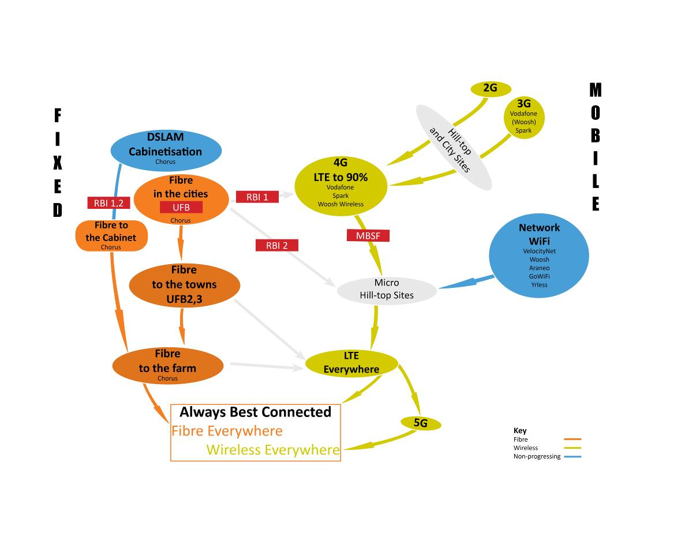
Proposed telecommunications development roadmap for Southland. Green indicates LTE development, Orange indicates fibre-optic cable development and blue indicates non-progressing solutions.

Fibre Everywhere
Because single-mode fibre-optic cable reticulation provides the foundations for almost any cable telecommunications protocol, providing fibre-optic reticulation to every dwelling in Southland would be an investment that will not become obsolete within any foreseeable future and its utility can be easily upgraded over time merely by changing out the termination electronics at relatively low cost.
Recognising the age of the Southland underground telephone reticulation network and its design transmission limits, and the first objective may be approached by concentrating effort in the first years towards laying fibre-optic cable from exchanges to each and every cabinet. These cabinets are, in turn, augmented with the installation of adjacent low-cost DSL cabinets. In some circumstances where the number of subscribers connected to a cabinet are low, back-haul from the cabinets could be provided by wireless, or the cabinet could be dispensed with and fibre-optic cable be extended to the subscribers’ premises.
The underground copper telephone network in Southland was largely laid from the late 1970s through to 1989. These cables are coming into its fourth decade and they have a 50 years design life. The cable reticulation is serviceable and when the cross-connection cabinets are swapped out with low-cost DSLAMs, reasonable broadband service is possible for limited distances. Typically, Southland rural cable reticulation uses a constant gauge, 0.63mm PEFUT cable design, providing a useful DSL transmission range of around 6.8km (See Appendix 2). In most cases it is necessary to overlay the cabinet feeder cable with fibre-optic cable to provide sufficient backhaul capacity and this is where most of the expense lies in rural areas.
Chorus has been actively “cabinetising” their local loop in the towns and cities for some time as by using their existing underground duct networks to pull through the fibre-optic backhaul at low cost. Under RBI1, Chorus has made some useful inroads to cabinetise some rural areas in Southland. The strategic value of the cabinetisation programme lies in its ability to provide cable-based broadband service to a (limited) number of customers at relatively low cost, but at the same time establishing the foundations for eventually overlaying the remaining copper reticulation cable with fibre-optic cable.
An interim solution proposed by some network providers is to provide low-cost wireless backhaul to remote Chorus cross-connect cabinets and install their own DSLAMs adjacent. This solution is especially attractive where the wireless backhaul can accommodate the traffic and the cost of laying fibre-optic cable is high. However, it can still only be seen as an interim (10 years) solution because of the inherent shortcomings of copper cable discussed earlier.
Because copper cable has very high transmission loss compared with fibre-optic cable, the copper reticulation cable cannot be seen as a long term, high-capacity reticulation solution. Compounding the design transmission limits is that while ADSL and ADSL2 can withstand the very significant electric fence interference experienced in rural areas, at present there is no VDSL mitigation. For this reason, providing much higher bandwidths than those already experienced in rural areas will be difficult.
That said, there is some urgency to overlay the copper network due to its age, which manifests itself in deterioration in transmission performance (through water assisted corrosion, but also through impedance mismatch from repair joints) and lack of capacity. This will require continuous reinvestment, either way.

LTE Everywhere
The wireless technology pathway we propose falls into three parts: wireless technologies that lead to ubiquitous 4G LTE deployment; interim technologies that provide adequate service now, but are unlikely to be able to scale to provide universal service, or are technologically limited; and those technologies that lead to providing widespread deployment of fibre-optic enabled services on an interim basis. The model is now described.
We back LTE as the development path for wireless communications because it is specifically designed for telephony-computer convergence and so works well for both cellular and data transfer. It is widely supported by telcos and the CPE is affordable and plentiful. There is no doubt that this is the technology path of preference for 4G in the industry.
A further advantage of LTE is that it supports low-cost, low power repeaters. Most of Southland has cellular coverage that is provided by relatively easily accessed hilltop stations. To extend the network further into the hinterland requires adoption of techniques pioneered by the smaller telcos, where minimalist sites with farm track access, powered by solar PV are the norm. These could be upgraded over time to LTE sites, providing at once improved data transfer rates and introduce cellular telephony.Any deployment will need to lever from existing investments and arrangements and the model set out above describes how this could be achieved.
We do have some reason to be somewhat cautious of LTE: our experience tells us that the MIMO technologies, which promise much increased data transfer rates over a single channel and are well integrated into LTE, do not work well in wooded and farming areas. At its core, MIMO relies on multipath propagation and in rural environments there is an absence of useful reflectors to support MIMO; instead there is a super-abundance of geographic features that are good only for signal absorption.
The wireless non-progressing technology is Wi-Fi. Wi-Fi was never designed to provide community-wide Internet service, but the low cost, ready availability and low power consumption of the access points allowed entrepreneurs to deploy networks quickly and at low cost. It is used for everything from providing hot-spots to rural network access to providing backhaul. In as far as it goes, the service Wi-Fi provides has been exceptionally good and the coverage has been very useful. It is well suited to small, very low cost hilltop sites. The difficulty is that Wi-Fi protocols deal poorly with wide-area, scalable deployment and were never designed to provide carrier-grade service. Its use of unlicensed radio spectrum means that catastrophic interference from other users can never be discounted. Bandwidth and customer bandwidth management is very limited compared to those available from purpose-designed protocols and standards.
Another solution would be to arrange a community and customer funded buyout of the Woosh Wireless network in Southland, assisted with RBI and MBSF funding, to form a community co-operative company, which would be responsible for upgrading the Woosh Wireless 3G technology to LTE and then operating the network.
While Vodafone and Spark roll-out their 4G networks, 5G technology development has begun. It is widely agreed that 5G will operate on radio spectrum between 10GHz and 100GHz. Atmospheric and rain attenuation at these frequencies is severe, which will fundamentally limit 5G’s effective range. It should thus not be seen as a long-range solution as its operating range will be less than one kilometre without active repeaters.
Very high data rates are anticipated for 5G, but currently the analogue front-end radio components are struggling to deliver the necessary performance required. Given the expected rate of technology development, where it takes roughly 4 to 5 years for a technology to get beyond research laboratories and another 4 to 5 years before it becomes affordable, it is unlikely that 5G CPE will be affordable and widely deployed within the next 10 years. 5G wireless technology need not be considered as a widely useful deployment tool for rural telecommunications within the 15 years’ horizon of this proposal.

Proposed Southland Pilot Project
A pilot project in Southland offers the ability to trial and demonstrate future-proof deployment models for New Zealand. Southland’s proven track record in this area also allows Government to trial deployment methodologies in a low risk and accountable manner.
Venture Southland proposes to work in partnership with MBIE and preferred telecommunications network providers to develop an agreed, fully-costed, and integrated technology roadmap that can be achieved over a 15 year period. Once such a roadmap is agreed, Venture Southland proposes to work in partnership with MBIE and telecommunications network providers to award funds to UFB2, RBI2 and MBSF projects in Southland, and oversee their deployment and acceptance testing. The components are described in the diagram below, which indicate the priorities and likely network partners.

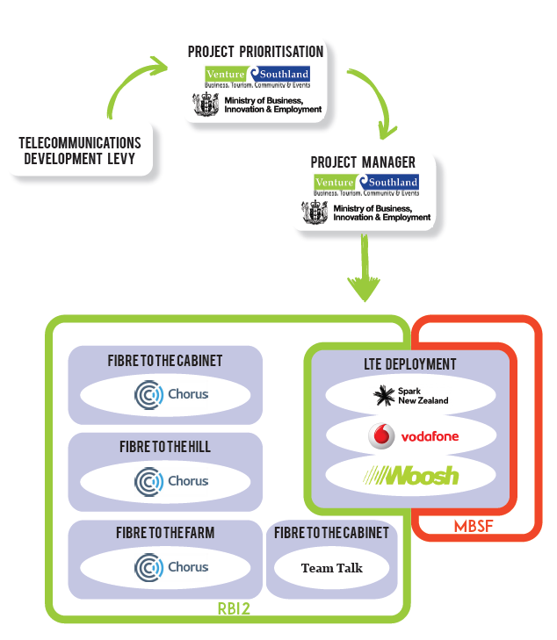

It is often overlooked that New Zealand’s remarkably diverse geography must be served by an equally diverse infrastructure; a long, skinny telecommunications network design that suits the West Coast does not match the Southland Plains, for example. Regional planning can more easily take advantage of and be attuned to geographic features, population trends and such like than centralised planning.
One advantage that smaller cities such as Invercargill have over large cities is that the consequentially smaller networks can be understood by a single person. For example, just the backhaul network for Auckland is more complicated than the entire Southland reticulation network. This means that it is possible to minimise operating overheads in Invercargill compared to Auckland, or even Dunedin.
In this light, and taking into account the technological constraints raised earlier, Venture Southland proposes a pilot programme to deliver an integrated solution that will deliver marked improvement to Southland broadband and cellphone access through an innovative application of RBI, UFB and MBSF allocations due to Southland. In essence, it is proposed that Venture Southland act as a bulk funder to manage a roll-out of terrestrial Internet and cellular services in the region.
Venture Southland would to provide the following services to MBIE to ensure that an optimal outcome is reached:
- Work with telcos, local wireless providers and the community to prioritise UFB, RBI and MBSF initiatives in Southland,
- Work with telcos, local wireless providers and the community to prioritise UFB, RBI and MBSF initiatives in Southland,
- Provide oversight and advice for the deployment of network infrastructure,
- Oversee network compliance and acceptance testing
- Monitor operational performance.
This sort of work is not new to Venture Southland: during its roll-out, Venture Southland was responsible for reporting to Ministry of Education and Ministry of Economic Development on capital expenditure on, and performance of, the Woosh Wireless network that was funded under the Major Regional Initiative and Project PROBE. This included of acceptance testing and preparation of completeness certificates. For the first two years of its operation, the Woosh Wireless network in Southland was effectively owned by Venture Southland by way of a General Security Agreement, and Venture Southland was responsible for reporting to its Councils on developments and performance. Venture Southland also ran a customer local market penetration programme and Connecting Communities Programme prior to network deployment to drive up customer demand.

Appendix 1. Metcalfe’s Law and Southland
It is not always grasped by some telecommunications providers that telecommunications networks differ markedly from other utility networks: unlike, say, a power utility where connecting one more customer to the network benefits that customer, a new customer on a telecommunications network provides utility to himself, but also some 3 billion other users who can now contact him. Metcalfe’s Law describes how the utility (or value) of a telecommunications network increases by the square of the number of its users. What is not so obvious is that this law points to a critical mass of connectivity after which the benefits of a network grow larger than its costs. The difficulty is that the costs are not necessarily accrued by those who collect the revenue, which is where cross subsidisation strategies becomes important.
Most telecommunications experts will be familiar with Metcalfe’s Law, which describes how the utility (or value) of a network increases by the square of the number of its users (because, unlike service utilities, telecommunications networks provide service to both the calling and called parties).
There are two corollaries to Metcalfe’s Law that are not so well known:
- Metcalfe himself observes that his law points to a critical mass of connectivity after which the benefits of a network grow larger than its costs. The number of users (N) at which this critical mass is achieved can be calculated by solving
CN=A(N-1)²
which quickly simplifies to
CN=A(N)²
where C is the cost per connection and A is the value per connection. The N at which critical mass is achieved is:
N=C/A.
It is not much of a surprise that the lower the cost per connection, C, the lower the critical mass number of users, N. And the higher the value per connection, A, the lower the critical mass number of users, N.
- Melody shows that the economics of network expansion are such that the calling opportunity multiplier is always higher than 2, meaning that the unit costs of network extensions can be more than twice the telco’s average costs per customer before high cost subsidies need to be considered at all. The incremental revenue benefits to the telco will be much greater than the charges billed to the additional subscribers, as there will be increased calling by those already on the network to the new subscribers. When this is combined with the fact that rural and remote area subscribers generally use the network at a higher than average level and incur even higher charges due to the much greater proportion of long distance use, several times the average customer extension cost can be justified on a cost recovery, if not a profitable basis, when a network wide analysis is undertaken. This helps explain why universal service need not be a significant subsidy issue in most countries.
In Southland, we have been able to capture the costs of rolling out the Woosh Wireless network and are able to demonstrate that Metcalfe’s Law is approximately held to be true, as set out in Figures 1(a) and 1(b).
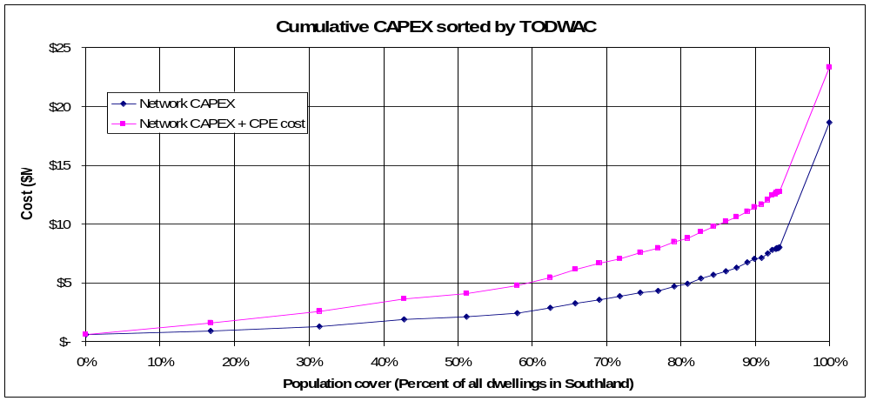
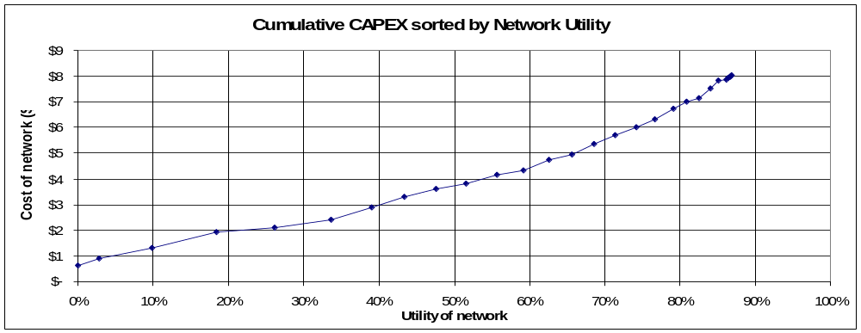
Figure 1. Southland wireless broadband Internet network CAPEX, (a) as a function of coverage, and (b) as a function of utility as described by Metcalfe’s Law. Note that in 1(a), the last 5% of subscribers are provided with satellite service.
- For most people, telecommunications has little price elasticity: people need it at whatever the cost (within reason).
- Rural Broadband Initiative (RBI) is not extending rural broadband coverage in Southland over that already achieved by Woosh Wireless in 2005
- A minimum target market penetration for broadband in the order of 95%, in both rural and urban areas. This is Venture Southland’s conclusion from applying Metcalfe’s Law, which states that the utility of a network increases by the square of the customers connected.
- A corollary to Metcalfe’s Law: there is a critical mass of connectivity after which the benefits of a network grow larger than its costs
- A further corollary is that the last customer connected is the most valuable customer for a communications network, as opposed to a utility network where that customer is the least valuable in terms of other customers.
- Broadband connection is more important for rural customers than for urban customers. A long term strategy is required to ensure that all rural customers can be offered both fibre-optic connectivity (noting that underground twisted-pair (telephone) copper cable had become universal in Southland by 1990) and 4G service.

Appendix 2. Local Loop transmission limits
Between 1979 and 1991, a concerted effort by New Zealand Post Office and then Telecom New Zealand saw the replacement of Southland’s antiquated open-wire party lines and manual telephone exchanges with the latest technology: underground, copper cable reticulation providing individual service, meeting the transmission standards set out for ISDN technology. This cost in the order of $10M per year, including telephone exchanges and transmission bearers.
In the rural areas, the cabinet reticulations were designed for fixed gauge 0.63mm PEFUT cable with the intention of eventually swapping out cross-connect cabinets for electronics. This gave a useful design range of 6.8 kilometres from any cabinet to any customer. Not coincidently, the ISDN transmission limits are very close to today’s DSL transmission limits, showing a way in which an interim solution can be forged.

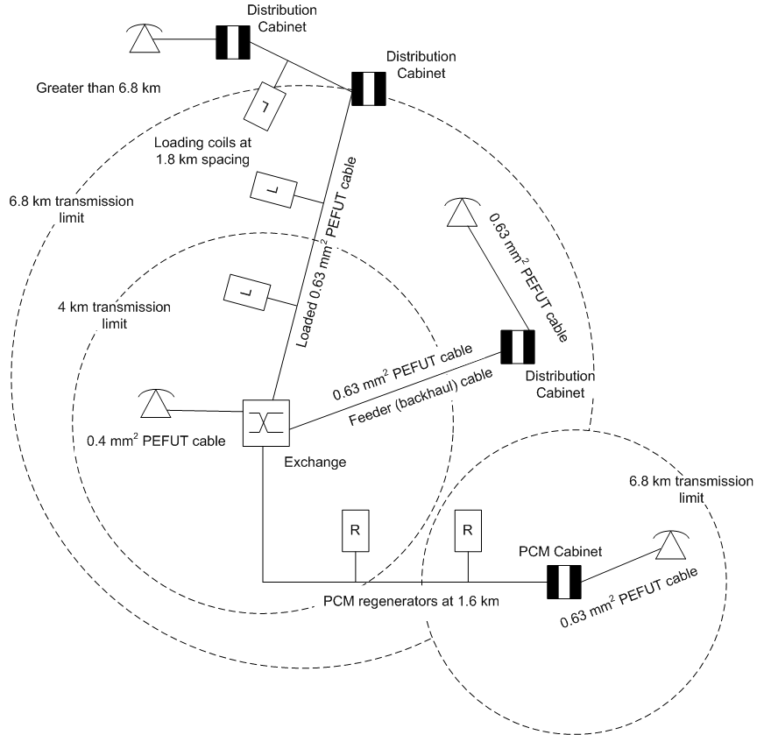
Southland NZPO copper cable reticulation ISDN design rules
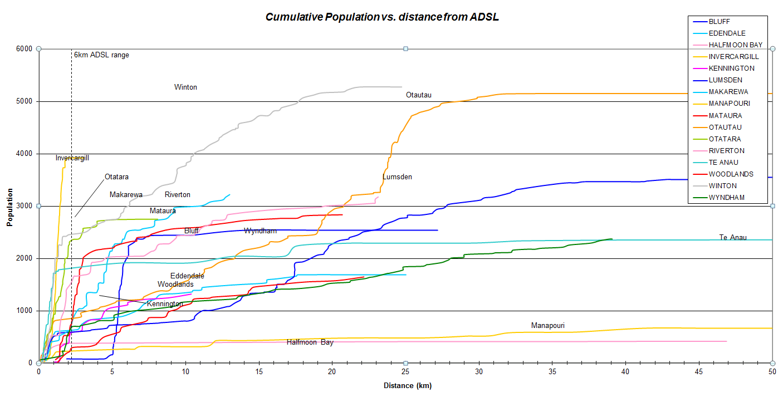

Appendix 3. Some estimates of the cost to deploy high speed broadband in rural Southland
It is possible to estimate the costs to deploy high-speed broadband throughout Southland from first principles to obtain some useful indicative measures to gauge the efficacy of different technologies and methodologies. The estimates can be used with some confidence in lieu of more refined planning materials.
Providing FTTH (Fibre-optic To The Home) capable of 100Mbps to all rural Southland dwellings and farms will cost in the order of $75M and $112M, requiring an effort of some 42,800 man-hours. At best this work could be completed in 5 ½ years by a workforce of 40 staff, but realistically it would take 10 years.
Providing Fibre-optic To The Hill-top and deploying a wireless broadband network capable of 10Mbps to over 96% of Southland’s 17,300 farms and dwellings will cost in the order of $21.5M and could be completed in 2 ½ years. Some 2,400 farms en route to the hill-top sites could be connected to the fibre-optic cable and obtain 100Mbps service provided no existing fibre-optic cable is used. This would also allow for upgraded cellphone access throughout Southland.
Providing fibre-optic cable to schools will cost in the order of $13M and could be completed in 2 years. A new fibre deployment would allow around 2,400 farms and dwellings to be connected to 100Mbps service. Adapting existing fibre optic cable would reduced the cost and effort, but no farms or dwellings would be able to be connected to the cable.

Estimate assumptions
Known facts and rules of thumb, based on Venture Southland experience to date, census and other data:
 | Population of Southland: | 92,000
 | Population of Invercargill | 50,500
 | Number of residents per dwelling | 2.4
 | Length of public roads in Southland | 7,200km
 | ITU cost to build a telecommunications network in 1997 | $US1,500/line
 | Cost of fibre-optic reticulation in Invercargill | $2,500/line
 | Cost to upgrade a major hill-top site in Southland | $100,000/site
 | Cost to establish a minor hill-top site in Southland | $50,000/site
 | Cost of fibre-optic cable | $4/m
 | Moleplough cable | $5/m
 | Trench laying cable, easy conditions | $7/m
 | Trench laying cable, urban | $70/m
 | Aerial deployment of fibre optic cable | $3/m

Estimate for a rural FTTH (Fibre To The Home) deployment in Southland
1. Estimate by road distance
If we assume that
For FTTH, every road in Southland will need to be cabled
Moleplough laying for 60% cable laying
Rural trenching for 40% of cable laying
Dwellings to be served is (92,000 – 50,500)/2.4 from (1) and (2)
i.e. 17,300 dwellings (14.)

From( 4), (9), (10), (11), the total cost of fibre-optic cabling is:
7,200km x 1000m/km x (0.6 x $5/m + 0.4 x $7/m + $4/m) = $71M

This is possibly a little high as not all roads will have dwellings at the far end. On the other hand, estimates for laying could be optimistic.
2. Estimate from ITU
The ITU guidelines indicate for a copper network, from (5), (14),
17,300 dwellings x $US1,500 / 0.7 US/Kiwi x 1.4 for CPI since 1997 = $52M
This is probably too light given that urban costs to deliver service will be cheaper than rural, so this can be regarded as an absolute minimum.
3. Estimate from Invercargill from Ultra-fast Broadband Initiative modelling
Using the fibre deployment cost for Invercargill using (6), (14) gives another minimum of
17,300 dwellings x $2,500/dwelling = $43M.
This is also likely to be much too low for rural deployment because of distances in rural areas. Rural costs could be 50% higher once cheaper laying costs are offset by increased fibre runs, giving $65M.
Summary
If we average our estimates above (through applying the Central Limit Theorem), we arrive at $62M. A uncertainty of 20% would be realistic, so the cost of providing fibre-optic cable to all of Southland can be expected to be between $50M and $75M.
These prices do not include the subscriber lead in, or engineering and administrative overheads which can typically be expected to cost an additional 50%. This gives a total connected cost of between $75M and $112M, with an average of $93M. (15)
Assume that the distances for the roads estimate are about right. If we allow one gang of 4 men can moleplough 1km of cable a day, and trench 450m of cable per day, the work will take
7,200km / (0.6 x 1gang-day/km + 0.4 x 1 gang-day/0.45km) x 4 men/gang =42,800 man-days (16)
At 235 man-days per man-year, to install the cable will take 182 man years. Allowing 20% overhead, gives 220 man-years. A team of 40 staff working solidly for at least 5 ½ years is required. Given the logistics of such an undertaking, tooling up and equipment procurement, 10 years is more realistic.

Estimate to provide Fibre to the School in Southland
Assuming that all fibre optic will be new, a network topography for Southland that essentially follows the Southern Scenic Route from the Catlins, through Invercargill and on the Tuatapere before heading to Te Anau, supplemented by another route traversing from Pukerau through Gore, Lumsden, Mossburn and Te Anau, and an additional route traversing from Bluff, through Invercargill, Winton and Lumsden to Athol requires approximately 1000km of cable. (17)
If we use the costs derived above (15) on a proportional basis, the cost to deploy fibre optic cable to the schools is 1000km/7200km x $93M = $13M. (18)
On the same basis (16), the effort will be around 182 man-years x 1000km/7,200km = 25 man-years. This could be achieved realistically in 2 years.

Estimate to provide Wireless to the Hilltop plus provide new and upgraded sites
This will provide at least 10Mbps to over 96% of all Southland dwellings.
To a first order, the scale of backhaul to hilltops will be the same as for schools (17), plus, say an additional 10km per wireless site. Based on Woosh Wireless network of some 30 sites, augmented by 10 new sites are needed to provide near universal coverage,
1000km + 40 sites x 10km/site = 1400km,
using (18), a total of $18M is required to deploy fibre-optic cable.

The cost to provision the hilltop sites from (7), (8)will be:
30 sites x $100,000 + 10 sites x $50,000 = $3.5M

i.e. the cost to provide wireless broadband coverage to over 96% of Southland at 10Mbps is
$18M + $3.5M = $21.5M.
The work required for the cabling is (16) 1400km / 7200km x 182 man-years = 35 man-years, possible in two years, but more likely three years.
If the cable to be deployed is all new, some 2,400 rural dwellings and farms could be connected en route. Many of the hill-top sites are co-sited with cellular telephone operators and improved cellular service would also result.

Summary
Fibre to 100% of dwelling in Southland at 100Mbps will cost between $75M and $112M. A team of 40 staff would be required to work solidly at this for 5 ½ years to undertake this work and would more realistically take 10 years. Planning effort is not included in this time allowance.
Fibre to the schools in Southland at 100Mbps will cost $13M. It should be possible to undertake the work in 2 years. There is no benefit to the community outside of the school itself and, if the deployment is all new cable, 2,400 farms and dwellings.
The cost to deploy a wireless broadband network to Southland providing 10Mbps service to over 96% of dwellings in Southland will cost $21.5M. Some 2,400 farms and dwellings would be able to connect at 100Mbps to new cable. This work should be achievable within 3 years.
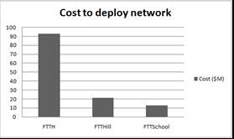

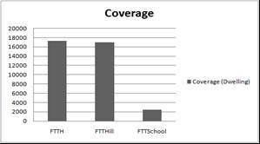

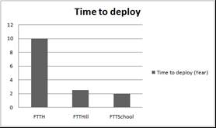

Appendix 4. Digital Dividend
In 2008, Venture Southland submitted to MED on the opening up of the 700MHz spectrum, or Digital Dividend. The submission centred on the need to ensure that the 700 MHz Band is used so that it best serves rural and remote populations, for which this band is well suited, and the rapid deployment of a ubiquitous, affordable and universal broadband network. We are also committed to supporting any approach that extends and improves rural and remote cellular coverage.
It would be a waste of a valuable, scarce economic resource for the 700 MHz Band to be used to provide broadband access for areas that could be alternatively served with higher frequency, S-Band, equipment. This comes about because S-Band and higher frequency deployment is not well suited for rural coverage due to the very high absorption losses from trees and macrocarpa hedges at those frequencies, but not the 700 MHz Band. In short, we see the 700 MHz Band as a first priority providing in-fill coverage where population densities do not make S-Band deployment economic.
We express our concern that the economic prosperity to the nation that can be brought about by providing comprehensive, affordable, and universal wireless broadband to rural areas through using the 700 MHz Band far outweighs any short term profits to Government that can be obtained from leasing the spectrum. We urge that any tendering process gives higher ranking to bidders who will actually deploy a useful network to rural and remote areas than just award leases based on bid price.

We suggested that the German approach (Digital Dividend: Insights for spectrum decisions, ITU, August 2012) to most effectively utilise the 800MHz spectrum freed up by the digital dividend. It can be summarised:
• Four priority classes are categorized:
– Priority 1: Towns/villages with less than 5 000 inhabitants;
– Priority 2: Towns with 5 000 to 20 000 inhabitants;
– Priority 3: Towns with 20 000 to 50 000 inhabitants;
– Priority 4: Towns/cities with more than 50 000 inhabitants.
• In terms of these priorities, each Federal State compiled its own list of all areas needing coverage.
• There is a general requirement for each assignee to meet the obligation with 800 MHz spectrum.
• Other technologies are credited (with the exception of satellite).
• The degree of coverage to be met is 90 per cent of the population by 2016.
• Towns of priority 2 may be provided with broadband access based on the usage of frequencies in the 800 MHz band not before a percentage of 90 per cent of towns/villages of priority 1 has been provided with a sufficient broadband access, regardless the technology used. Towns of priority 3 may be provided with broadband access based on the usage of frequencies in the 800 MHz band not before a percentage of 90 per cent of towns of priority 2 has been provided with a sufficient broadband access, regardless the technology used. Towns/cities of priority 4

Appendix 5. Some observations on Telecommunications Infrastructure
Robin McNeill
Venture Southland
10 June 2013

Telecommunications
- For most people, telecommunications has little price elasticity: people need it at whatever the cost (within reason).
- Rural Broadband Initiative (RBI) is not extending rural broadband coverage in Southland over that already achieved by Woosh Wireless in 2005
- A minimum target market penetration for broadband in the order of 95%, in both rural and urban areas. This is Venture Southland’s conclusion from applying Metcalfe’s Law, which states that the utility of a network increases by the square of the customers connected.
- A corollary to Metcalfe’s Law: there is a critical mass of connectivity after which the benefits of a network grow larger than its costs
- A further corollary is that the last customer connected is the most valuable customer for a communications network, as opposed to a utility network where that customer is the least valuable in terms of other customers.
- Broadband connection is more important for rural customers than for urban customers. A long term strategy is required to ensure that all rural customers can be offered both fibre-optic connectivity (noting that underground twisted-pair (telephone) copper cable had become universal in Southland by 1990) and 4G service.
- The 700 MHz digital dividend needs to be managed very carefully: in places with larges plains, such as Southland, 700MHz transmitters will have a wide physical range and so limit the number of cellsites that can be deployed for a given area without causing interference; this means that the number of users/km2 that can be accommodated is much less than for an area bounded by hills. It would be very easy to squander 700 MHz connectivity on customers who could be more efficiently served by S-Band customers (Annex 1 sets out the German solution, which may be adapted for New Zealand).
- While New Zealand’s performance is currently about average in the OECD, this overlooks that many countries (e.g. Germany) have very aggressive approaches to improving their telecommunications and even after accounting for RBI and UFB, New Zealand will likely lag in the near future at least.
- UFB and RBI penetration is extremely low at present (about 1%) and it would appear that there is a systemic problem of considerable proportions that needs to be addressed.

Southland Digital Strategy (2008)
- [Objective is:] Southlanders can enjoy a world-class, affordable, ubiquitous telecommunications service at a universal price.
- Customer demand:
  - “Always on, always available”
  - “Always best connected to the best service”
  - “Secure”
  - “Affordable”
  - “Content and services match user needs”

Technology:
  - It takes 4 – 5 years for a technology to become available after first reporting in learned journals,
  - It takes another 4 – 5 years for the technology to become affordable,
  - We know what the network components will be for the next 10 - 15 years
  - The technology doesn’t matter too much as it will be obsolete in 6 years, even though network components will be used for 10 to 30 years afterwards.
  - Cognitive radio may well become a significant technology development

Appendix 6. Southland Region Broadband Review
CONFIDENTIAL

Report:

Proposed activities to mark the opening of Awarua Rocket Tracking Station and the launch of the Ariane 5 ATV mission

Prepared By: Tony van Horik,
Advanced Technology Solutions Ltd
For: Venture Southland
Date: 29 June 2015

Advanced Technology Solutions

Client Name: Venture Southland

Client Ref. No: 20150501Project Type: Report
Project Title: Proposed activities to mark the opening of Awarua Rocket Tracking Station and the launch of the Ariane 5 ATV mission
Consultant(s): A van Horik
Version: 29 June 2015
Filename: 0000.doc
Status: CONFIDENTIAL

Table of Contents
Table of Contents 35
1 Executive Summary 36
1.1 Purpose 36
1.2 Introduction 36
1.3 Overview 36
1.4 Conclusions and Rercommendations 37
2 Background and Introduction 41
3 Scope of Review 41
4 Basis of Analysis/References 42
5 Summary of Regional Broadband Services Development 43
5.1 Introduction 43
5.2 The Mobile voice services platform 43
5.3 The Rural Broadband Initiative 44
5.3.1 Government Requirements 44
5.3.2 Internet Survey results 44
5.3.3 Vodafone RBI services 44
5.4 Ultra-Fast Broadband infrastructure development programme 46
6 Appendix A: 48

Executive Summary

Purpose
Venture Southland has commissioned ATSL to review progress on the current RBI and UFB programmes in the region. This is a continuation of previous assessment work carried out by ATSL in December 2007 following Southland’s “Whole of Community” broadband programme initiated in 2002.
IN early 2015, two surveys were undertaken by Venture Southland to assess customer satisfaction with Internet and Mobile Services, and, coupled with a quantitative measurement of mobile phone coverage; this information has been used to evaluate the current quality of telecommunication services provided in Southland.
The effectiveness of the current RBI and UFB programmes is discussed with a view to establishing a firm foundation and approach to any further regional telecommunications infrastructure development.

Introduction
Since 2002, Venture Southland’s has been an active participant with central government and suppliers in the development of telecommunications infrastructure to support local industry, schools and residents. The success of these early efforts is undisputed but momentum must be maintained as without this intervention, low population density areas such as Southland are not likely to attract adequate investment from private profit driven suppliers.
The government (through MBIE) has released a number of ROIs to local councils and suppliers for the expansion of the current UFB and RBI programmes. In addition it has asked for input into the expansion of mobile phone coverage areas through a Mobile Black Spot Fund. Southland Regional Council, through Venture Southland, intends to respond to the ROI-Support .

Overview
With Southland being a largely rural community and distant from international interconnection points, it is inevitable that telecommunication suppliers will focus a large portion of their investments on more profitable and highly competitive markets. On a per capita basis, Southland's GDP is high, but in order to maintain and grow this, continued investment in essential supporting infrastructure, such as telecommunications, is required. Based on past experience, it is apparent that this investment will only be made through the continued intervention of central and local government.
Southland's use of, and dependency on, modern fit-for-purpose telecommunication services is high. The productivity (and personal safety) of the roading, agriculture and tourism industries in the region are highly affected by the availability of mobile phone and broadband coverage. With ever increasing dependency on, and demand for modern voice and Internet services, there is and is an ever increasing digital divide for the rural sector through lack of timely investment as enjoyed by most major urban areas.
It is clear from Venture Southland's recent surveys the service improvements are required in a number of areas. In order to create the most benefit to the region on any further infrastructure spend, it is essential that this is done as a partnership between suppliers, and local and central government.

Conclusions and Recommendations
General
- Southland has historically been above the New Zealand average for the take up of broadband services and (barring current UFB) this trend is continuing -especially in the rural areas. It is clear, however, that with the increased availability of, and dependency on internet based services, customer expectations are rapidly increasing and survey results show that more than 40% of users are dissatisfied with the performance of their service. A large proportion of users claim that the service is "unusable" during peak times. This is true for rural areas in particular.
- While the uptake of mobile technology (internet and mobile phones) is at least on par with the rest of New Zealand, it is evident that the quality of the services provided throughout Southland is significantly below requirements with close to 50% of users regularly experiencing problems that impact their business and personal lives.
- With the opening up of telecommunication competition that included infrastructure, the Government has created an environment where markets with perceived low returns, such as Southland, are being largely ignored for major investment. In the past 20 years, any significant investment in telecommunications infrastructure has only come about as a direct result of subsidies, lobbying, and intervention from local and central government. Without this continued intervention, the quality of telecommunication services in Southland will continue to fall behind the rest of the country and growth opportunities will be hindered..
- Over the past 10 years, Venture Southland has proven itself to be a worthy partner with central government and telecommunications providers for the enhancement of services in Southland. (No other Territorial Authority has been as successful in this). This organisation has a good understanding of the needs of the region and has been a worthy advocate for the people and industries of Southland. A partnership with this organisation is essential for extracting the most benefit from any further investment by both central government and service providers.
- Southland continues to be a powerhouse for agriculture and tourism and there are significant indirect economic benefits to New Zealand to further grow these industries through the availability of ubiquitous, fit for purposes, telecommunications services. For this reason, the strategy by central government for attending to high population areas first must be modified to benefit these highly productive industries. A more targeted approach is therefore required to gain maximum benefit for any further infrastructure investments.
Mobile Voice Services
- While less than 1% of Southland residences do not have a mobile phone, 47% rural residents and 39% urban residents regularly experience mobile coverage problems which significantly impacts their lives. This clearly indicates that while mobile phone penetration is high, the coverage provided is significantly below requirements.
- With only minor exceptions, much of the existing mobile network infrastructure and subsequent coverage areas are duplicated in Southland. The proliferation of duplicate/overlapping mobile network infrastructure by Vodafone and Spark in low population density areas needs to be reassessed with a view to sharing of that infrastructure, especially where that infrastructure is being subsidised by government. Competition requiring duplication of infrastructure does not appear to be serving the Southland region well in low population density areas and creates a disincentive for suppliers to invest. With more revenue on offer through roaming arrangements, there will be a greater incentive to invest in marginal areas.
- It is clear that large areas of Southland have little to no mobile phone coverage. With limited funds, a targeted approach is required to achieve the greatest impact (economic and social benefit) for key industry sectors. Any further builds of infrastructure should therefore be undertaken in consultation with the local economic development agency. Venture Southland has identified three high priority areas for the expansion on mobile services which cover main arterial routes, tourist areas and farms.
Rural Broadband Programme
- Without a quantitative analysis of end user performance, it is difficult to determine whether or not a supplier has met its contractual service provision obligation under the RBI programme. The Venture Southland survey, however, does create sufficient concern for further investigation regarding the performance and capacity of the this network. Vodafone states that the network performance is "managed carefully", but much more transparency is required as to how this is done and what the results are.
- The cellular network (including data) is by its nature a contestable network and there are no guaranteed performance levels. It is not possible to prioritise data services to fixed mobile RBI customers and the loading on a cell site will vary greatly during the course of a day and over the peak tourist season. This appears to contradict the Government's requirements under the RBI contract.
- Irrespective of whether or not the RBI contractual connection performance has been achieved, the fixed cellular connection specification for minimum throughput needs to be reviewed as it currently appears inadequate to cope with modern Internet services and customer expectations.
- There are reports that in some locations cell sites have reached their capacity for fixed Internet connections under the RBI programme. While this has been stated by some Vodafone resellers and installers, it has not been stated by Vodafone and its position is that there is no hard limit on the number of RBI connections to its sites.
- Venture Southland is planning to undertake a co-ordinated Internet speed test survey in various areas to get quantitative data on service quality. The results of these tests should be used check against service provider obligations where government contracts are in place and inform further investment.
- Vodafone has plans to upgrade its RBI sites to LTE (no dates given) but this is again will only service as a stop-gap measure for high end non-mobile users and have limited geographic coverage. A modem change will be required for RBI connections to make use of this higher performing LTE service.

Ultra Fast Broadband Programme
- The current UFB programme will result in nearly 17,300 residences being able to access fibre broadband services in Invercargill, Gore and Mataura by June 2016 (Gore doesn’t start until August 2017). To date, around 13,000 residences in Invercargill have access with around 1,300 connections made.
- The take-up rate of 10.4% is below the national average of 12.8%. This lower than average uptake is seen as the result of; (1) fewer retailers in the region selling the service, and (2) lack of public awareness, promotion and information regarding the services on offer. There has also been feedback from some businesses of difficulty and delays in getting fibre installed.

Recommendations
- Preparation of a joint Long Term Strategic Plan for the Development of Telecommunication Services in Southland - to be undertaken jointly by central and local government with assistance from key suppliers (include cost estimates). This should provide a roadmap to a point where capacity and coverage become non-issues and ensure efficient investment to achieve the greatest benefit for the region in the shortest time possible.
- Establish a closer relationship and Statement of Works between local councils and suppliers in order to: (1) efficiently overcome council consent requirements; (2) better target infrastructure development for the community priorities; (3) stimulate demand for services; and (4) ensure any new buildings and building sites include telecommunications infrastructure consistent with the Long Term Strategic Plan.
- That mobile networks be extended into remote areas (where subsidies may be required) by building an "open" single network infrastructure which accepts connections from all national service providers through a "transparent" national roaming agreement (Note: Vodafone already has a selective roaming agreement with 2degrees).
- It is clear that because of the high level of customer dissatisfaction, expectations of the fixed broadband services are not being met in many areas. Networks are not maintaining pace with the ever increasing demand for Internet based services - especially in the rural areas where dependency on these services is high. Ultimately, therefore, fibre optic cables must be extended further into remote locations and innovative ways of funding and achieving this must be explored by local government with supplier input.
- It is understood from Vodafone that recent changes have made it possible for emergency services calls ("111") to roam between networks should the handset's home network not be visible. As this is a key issue for road and farm safety and more clarification is required as to the network conditions under which this occurs.
- With customer service expectation ever increasing, the minimum performance standard for the rural broadband service must be revised. The current "minimum peak" standard has set the minimum performance (average throughput of 45kbps over a 15 minute period) standard too low and is not being actively monitored.
- An open and transparent method of testing network performance should be established. Network providers must be encouraged to be more open regarding performance issues such that a realistic cost versus performance equation can be established and external assistance provided where appropriate. The involvement of an independent body such as the Telecommunications Commissioner is recommended. Minimum standards must also be revised on a bi-annual basis.
- Provide further encouragement for private wireless internet providers to share the fibre cable to rural schools in order to upgrade and extend internet access to the local community near the school. (Yrless and VelocityNet in Southland are implementing a small number of projects based on distributed Wi-Fi networks around schools to provide community broadband).
- Make greater use of the already established remote Woosh Wireless sites to provide higher performance broadband access should be considered.

Background and Introduction

The previous review undertaken by ATSL in December 2007 identified some key themes which are also reiterated within this review.
- Southland residents and businesses have an above average take up of communications technology which reflects their dependency on these services to prosper in a largely rural lifestyle and economy.
- In order to expand and provide fit-for-purpose telecommunication services to a largely rural economy, continued local and central government intervention is essential to assist suppliers to upgrade and expand their network infrastructure.
Venture Southland intends to respond to the government's ROI - Support (RBI 2, UFB 2 and Mobile Black Spot fund) such that it can play a more active role in ensuring that: (a) Southland businesses and residents are provided with price competitive, fit-for-purpose broadband and mobile phone services; (2) Southland priorities for coverage areas and industries are recognised; and (3) that investment levels are maintained in order to ensure access to modern internet applications. There is sufficient evidence to show that without the continued monitoring and intervention by local and central government, investment in telecommunication infrastructure in Southland would continue to be inadequate to support a largely rural economy.
The recent customer survey undertaken by Venture Southland indicates a high level of dissatisfaction among communities and business groups regarding the quality and access to broadband services and the sporadic nature of mobile phone coverage. Irrespective of the accuracy of the results of this survey, there is a growing need to ensure that the services being provided by ISPs are affordable and fit for purpose. Recognising the need for an independent quantitative analysis, Venture Southland is currently measuring Internet performance (speed test) at various locations throughout Southland. It has also commissioned OPUS to measure and map cellular coverage areas in key urban and rural areas.

Scope of Review
- Establishment of additional Mobile Hot Spots
- Analysis of the effectiveness/coverage offered by current sites
- Identify key areas for additional hot spots (use of Mobile Blackspot fund)
- Put forward a case for global roaming over the current and any new sites being established
- Analysis of the effectiveness of the RBI programme for Southland
- Have the suppliers met their contractual obligations for coverage and capacity

- Analysis of customer service uptake and satisfaction survey on rural broadband coverage (improvement/non improvement resulting from RBI programme)
- Overall effectiveness of the programme
- Suggestions for improvements using RBI2 funding available

- Analysis of the effectiveness of the UFB programme for Southland
- Has the supplier met its contractual obligation for coverage
- Analysis of incentives and inhibiters to customer uptake
- Overall effectiveness of the programme
- Improvements required and suggestions for use of UFB2 funding

Basis of Analysis/References
Establishment of additional Mobile Hot-Spots.
This review has been based on:
- A comprehensive measurement of mobile coverage signal strengths throughout the region undertaken by OPUS during first half of 2015. This survey measured signal strength in both urban and rural areas and identified areas where: (1) signal strength was good; (2) signal strength was sufficient to hold a call outside of a building; and (3) areas "unable to hold a call".
- Proposed infill sites prepared by Venture Southland
- Venture Southland Mobile and Internet Survey March to May 2015; provided 720 responses from across the region from users of Internet and Cellular services in both the rural (61%) and urban areas (39%). This was an online survey and was completed by a wide range of respondents from Stuart Island to Te Anau.
Rural Broadband Initiative (RBI 1)
This review was based on:
- Proposed infill sites prepared by Venture Southland
- Southland Mobile and Internet Survey 2015
- Information provided by Vodafone NZ regarding network performance and capacity for fixed data connections under its RBI contract with the government
- Cabinet upgrade information supplied by Chorus
- Southland Regional Broadband Audit; ATSL December 2007
Ultra Fast Broadband (UFB 1)
This review was based on:
- Southland Mobile and Internet Survey 2015
- UFB programme information supplied by Chorus
- Cabinet upgrade information supplied by Chorus
- Press release by Chorus re Southland UFB programme March 2015
- Chorus Regional Economic Dashboard

Summary of Regional Broadband Services Development

Introduction
- At 76%, Southland has a slightly higher than average Internet connection rate than the rest of the country.
- The rate of connections via a satellite service for Southland is significantly higher (at 13% of connections) than for the rest of the country (4-5%). This indicates a high demand in remote rural areas as costs for this service are significantly higher than any other form of connection.
- There is a high demand for both extended cell phone coverage and high reliability, faster Internet services from the agriculture and tourism sectors. Both these industries are highly rural based necessitating infrastructure builds in remote low population density areas.
- Woosh Wireless has an extensive wireless network throughout urban and rural Southland as a result of its supply contract resulting from an earlier government funding programme around 2005. With ever increasing demand for higher performance, this network now requires a significant upgrade in order to keep up with customer requirements and maintain its market share.
- Southland has a relatively low population density and the effectiveness of having competition through duplication of key telecommunication infrastructure from various suppliers begs the question as to whether this best serves the interests of Southland. There are currently three competing networks established, each providing around 90% population cover, with government funding support. Some rationalisation/consolidation may be useful.

The Mobile voice services platform
Demand
Mobile voice services are provided by both Spark and Vodafone throughout rural and Urban Southland.
Despite large areas of Southland having little to no mobile phone coverage, Venture Southland's survey indicates more than 99% of households have at least one cell phone and over 50% having multiple devices.
Ubiquitous reliable voice service is still the most sought after communication service in the rural and semi rural sector.
There is significant unmet demand from both the tourism and agricultural sectors. Lack of mobile voice service coverage significantly impacts the tourism industry as this is often the only form of communication which a tourist will have or use. Unanswered calls and lack of immediate response causes lost business for tourist operators (Ref; customer comments in survey).
Coverage
There is insufficient data available to establish what proportion of premises have reliable mobile phone service coverage and Venture Southland's survey results have been used as a substitute. The survey shows that only 48% of rural dwellings in Southland have mobile coverage inside their home compared to 73% in urban areas (The coverage statements and maps from providers is often greatly overstated)
The inability to have mobile phone coverage both at home and at work is a major productivity issue for many businesses.
Depending on location and business activity, it is not uncommon for a business employee to have a mobile phone for both the Spark and Vodafone network. Close to half of mobile phone users report to regularly experience problems which impact on their lives and ability to conduct business. This applies in both the rural and urban sectors.
While the RBI programme has provided the added bonus of extended mobile voice coverage to the rural community, the OPUS survey shows that there are still some significant "black spot areas" throughout Southland over major arterial routes, major tourist destinations and routes, and rural communities.
Signal strength measurements taken by OPUS for Venture Southland indicate that a significant number of major roads in Southland are without mobile phone coverage and at best "patchy". While it may be some time before full coverage can be achieved, major roads and tourist areas should be a priority for reasons of safety and economic growth. Preliminary work undertaken by Venture Southland has identified 3 potential mobile "black spot" sites which would significantly improve coverage along multiple state highways and high demand areas. Notably these are; Mossburn, Tokanui, and Ryal Bush.
The OPUS signal strength measurements show that to a very large extent the Spark and Vodafone networks overlay (duplicate) each other with only minor differences in coverage and quality in some areas. The question would therefore have to be asked as to whether the infrastructure investment would be more cost effective, and achieve a wider coverage area, with the deployment of a single network infrastructure and providing transparent roaming across the networks for the various provider handsets. Roaming for emergency services ("111" calls) already exists.

The Rural Broadband Initiative

Government Requirements
The RBI contract was awarded to Chorus for the Southland Region. Under the terms of this agreement, Chorus was to bring together both landline internet services and fixed cellular internet services though Vodafone. Chorus would provide upgraded and new rural cabinets to extend the reach of copper cable based DSL services, fibre optic cables to those feeder cabinets, fibre optic cable to Vodafone cell sites for backhaul, and fibre optic cable to many rural schools. A small number of more remote schools where to be provided with wireless or satellite systems for high speed Internet connectivity.

Internet Survey results
41% of rural businesses say that their internet service does not currently meet their needs and a further 10% say it won't meet their needs within the next two years. 53% of urban businesses say that their Internet service will not meet their needs within two years.

Vodafone RBI services
In the fulfilment of its RBI contract, Vodafone provides a fixed cellular data service either direct to rural customers or through a reseller with a wholesale arrangement. This service is delivered through their 3G HSPA+ which is designed to provide peak speeds of 21Mbps/5Mbps downstream/upstream. The Vodafone option provides a 30Gbyte data with telephone package for $95 per month with additional installation costs ranging from $99 to $199. This compares to Vodafone urban broadband plans of $79/month, sometimes reduced to $69/month for phone and 40Gbps
Under the terms of its RBI contract Vodafone must provide:
" an Access Seeker with an Internet grade “best efforts” bitstream service and enables an Access Seeker to offer its End Users fixed wireless broadband services".
A further requirement states that:
"The RBI Broadband Service (nominal 1500 byte packet): The service must be designed to have a peak throughput of at least 5Mbps downlink and 500Kbps uplink, and dimensioned to deliver a 99.9% probability of providing to any End User a minimum average throughput of 45Kbps downlink during any 15 minute period;"
Vodafone is to install 9 new cell sites and upgrade 19 existing sites, most of which have now been completed. This would provide RBI (internet) coverage to an estimated 80% of Zone 4 households. No service uptake figures have been provided.
Survey results
A survey of Mobile and Internet users undertaken by Venture Southland during March to May 2015 provided the following relevant results regarding Vodafone’s RBI service:
- A large proportion of rural households have an internet service delivered by wireless (40%-45%). (This is largely due to the prevalence of Woosh Wireless at and early stage; the Woosh network could be accessed by over 85% of Southland dwellings).
- 39% of rural customers state that their service is slow or unreliable;
- 41% of rural business state that their current internet service does not meet their needs.
Vodafone Performance
There have been numerous reports that while RBI service via Vodafone was available, the loading on the nearest cell site had reached capacity and no further connections could be made. Vodafone denies that there is a hard rule as to the number of connections to a site; however, it stands to reason that a limit would be imposed such that a service quality standard is maintained to existing customers. This limit appears to vary from upwards of 100 RBI connections. Notwithstanding this, the following press release places an interesting spin on the capacity of wireless broadband for a site.
Vodafone press release on 19 May 2015
"Vodafone switched on its newly built cell towers in both Centre Hill and Waikaia this month – as part of the Government’s Rural Broadband Initiative (RBI) – vastly improving mobile coverage in the area, and making high-speed wireless broadband available to over 1,300 addresses for the first time. "
The heart of the problem appears to lie in the low performance requirement set for service standards and the supplier’s ability to monitor and guarantee this. The 5Mbps minimum peak speed required simply sets a network connection capability and bears little reflection on service performance. The ability for the service to meet the “minimum average throughput” needs to be tested. Vodafone states that when a cell site reaches capacity, it will be upgraded. However, this is completely at their discretion. Numerous factors will affect an individual connection and a site's performance, but at this stage, there is no monitoring or transparency regarding the criteria to upgrade. Venture Southland’s survey provides sufficient evidence to warrant a closer look at service performance especially at peak load times (appears to be roughly 3pm to 8pm).
Technology Choice
The use of cellular technology to provide a "fixed" data connection is expedient at best. While major improvements have been made with the advent of 3G, 4G and LTE services, the technology should still be regarded as a mobile technology best suited for short session, intermittent use. Fixed line data networks have a significantly different usage profile and are likely to stress mobile network capacity, especially at peak usage times. The technology should therefore only ever be seen as an interim solution for fixed users.
The current RBI service is based on the 3G HSPA+ service. Although this technology in theory provides a 21Mbps downlink and an 5Mbps uplink, a number of (sometimes unpredictable) factors will significantly reduce these speeds for the average user. Vodafone has an upgrade plan to 4G over the next few years although a modem change will be required for customers to make use of the higher access speeds offered.

Chorus RBI services
Under the RBI contract Chorus provides an ADSL service to rural households via copper, fibre backhaul cable, and newly installed or upgraded roadside cabinets. The contract also covers fibre access to a number of rural schools, medical facilities and libraries.
The national objective is to provide broadband connection speeds of 5Mbps (or better) to 87% of rural New Zealand (81,000 businesses and households). Information on the Chorus web site indicates that some 45 rural cabinets will be upgraded to provide a better that 5Mbps service to an additional 3,100 lines and better than 1Mbps to 3,800 lines. This is a 5 year programme which began in 2012.
The programme also includes laying fibre cable to rural schools, which in a small number of cases has been shared with local internet wireless companies to extend and upgrade wireless broadband services to local communities and businesses close to the school. The Ministry of Education has developed policy and guidelines for schools to share the fibre cable and collocate privately owned equipment on the school premise.
A common complaint with regard to this service is the slow degradation of service as more customers are connected. Performance bottlenecks can be caused by congestion in a number of network elements of an end-to-end internet connection and therefore requires some technical expertise to properly investigate. With multiple parties involved, it is not uncommon for customers to experience long delays in rectifying performance issues.

Ultra-Fast Broadband infrastructure development programme
To date, the UFB programme being implemented by Chorus covers approximately two thirds of the urban Invercargill area (13,700 premises) with a further extension planned by June 2016 to make a total of 17,000 premises. Latest figures from Chorus shows an uptake of about 1,300 which equates to 10.4% uptake of those premises able to get the service. The national average uptake is 12.8%. This is between 2% and 7% below other major urban areas such as Dunedin and Auckland and is uncharacteristic of the region. The reason for the lower uptake is cited by Chorus and probably due to the small number of retail service providers providing interconnection in Southland.
Issues raised and comments by Venture Southland:
- High awareness but low understanding of how to connect
- It has been difficult to put forward expansion requirements of the UFB programme without fully understanding what the current programme is going to achieve. (Little information regarding Gore and Mataura)
- No retail drive to sell UFB (this is consistent with Chorus observation)
- Confusion by the public as to where the service is available and how to get it - no marketing campaign
- Needs a local champion to provide advice and advocacy [VS] therefore councils and LG need more information
- In order to achieve the greatest benefit for the region, Councils need to be part of the decision making process for infrastructure deployment
- Back haul can still be a problem as some services cannot operate due to network delays and capacity [Netflix]
- Internet service Speed tests are underway in various centres [Stewart Island, Winton, Te Anau, Oban] Host in DN. This will provide a quantitative analysis of network performance across the region
- Need a long term strategic plan (with cost estimates) that drives toward fibre to all premises is required. At this stage there doesn't appear to be one
- Get the Telecommunication Commissioner to be interested in network performance and coordinate testing of services to hold suppliers accountable
- Venture Southland could take up the role of promoting fibre services etc.
- UFB done to accommodate largest population areas but does not take into account, isolation/social factors, GDP, national market sector development (agriculture and tourism), regionalisation strategies

Appendix A:

Extract from the Vodafone contract with MBIE
PART B: WHOLESALE SERVICE

1 Wholesale Service Description

1.1 Vodafone will provide Access Seekers with the opportunity to purchase the “Vodafone Rural
Broadband” product set described in paragraph B1.3 below (the “Wholesale Services”),
which will allow Access Seekers to offer end users their own-branded wireless broadband and
voice services. These services are delivered from a Vodafone-approved wireless terminal
(“WT”) to the point of interconnect nearest to the rural region of the relevant Infrastructure
(“POI”) with the Access Seeker.
1.2 The Access Seeker will:
1.2.1 carry the data and/or voice traffic (as appropriate) from the POI, on its own
network; and
1.2.2 supply and install the WT (as approved by Vodafone) at the End User premises along
with any required wiring or external antennas in accordance with Vodafone’s
installation guidelines.
1.3 Vodafone will offer Access Seekers the following three products under the Wholesale Services:
1.3.1 the “RBI Broadband Service” – a best efforts broadband packet data service
described in further detail in paragraph 2 below;
1.3.2 the “Enhanced RBI Broadband Service” that offers its End Users simultaneous
delivery of the RBI Broadband Service and a prioritised traffic class (up to 40Kbps)
over a single wireless connection and which is described in more detail in paragraph
3 below. This service will be designed to support G.729 and will be available by 31
March 2012; and
1.3.3 the “RBI Broadband plus Voice Service” that offers its Ends Users the RBI
Broadband Service together with a voice service.
1.4 The Wholesale Services are not available for sale directly to End Users. However the Wholesale
Services are available for sale to Access Seekers.

2 RBI Broadband Service Specifications
2.1 The RBI Broadband Service is a wireless service that enables access to, and interconnection
with, that part of Vodafone’s network that connects End Users premises to Vodafone’s local
data network (or equivalent facility) and includes backhaul from that local data network back
to a POI. It provides an Access Seeker with an internet grade “best efforts” bitstream service
and enables an Access Seeker to offer its End Users fixed wireless broadband services.
2.2 The RBI Broadband Service (nominal 1500 byte packet):
• consists of a single “best efforts” IP broadband service. The service is designed to
have a peak throughput of at least 5Mbps downlink and 500Kbps uplink, and
dimensioned to deliver a 99.9% probability of providing to any End User a minimum
average throughput of 45Kbps downlink during any 15 minute period;
• is supplied to an End User by a wireless radio transmitter located at a Vodafone cell
site and a wireless terminal that has been installed by the Access Seeker in
accordance with Vodafone’s guidelines;
• transports an Access Seeker’s internet traffic from the WT at an End User’s
premises to the relevant Handover Point (as described in paragraph 5 below);
• has a mean one way packet delay of <1 second; and
• has no specific metric for packet delay variation or packet loss ratio.
2.3 The RBI Broadband Service will initially be based on HSPA+ technology operating in the 900
MHz band that is designed to provide the following peak speeds:
2.3.1 Downstream 21Mbps; and
2.3.2 Upstream 5Mbps.
2.4 Achievement of coverage such that 80% of Covered Households in Zone 4 can receive a rural
broadband service in the manner set out in paragraphs B2.2 and B2.3 above is based on the use
of a Vodafone-approved WT connected to an external antenna that is mounted at least 4.5m
above ground and that meets the requirements set out in the column headed “External
Antenna Specification” in the table in Appendix 1 - Engineering Design Standards (an
“Appropriate Aerial”).
2.5 The supply of the RBI Broadband Service is not conditional on a requirement that the Access
Seeker, the End User, or any other person must purchase any other product from Vodafone.
2.6 The following diagram illustrates the RBI Broadband Service:

Appendix 7. Southland Mobile and Internet Survey 2015

Southland Mobile and Internet Survey 2015

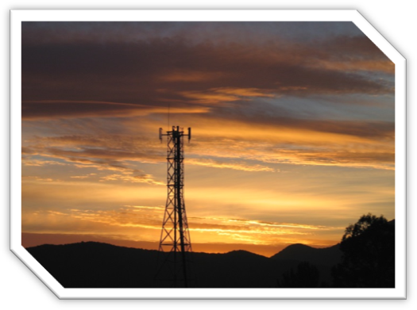
Full Report

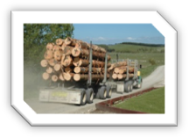
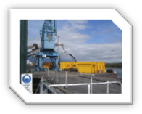
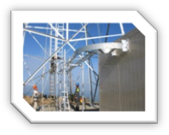
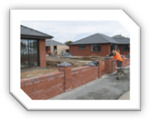



PO Box 1306
143 Spey Street
Invercargill 9840
03 211 1400

Contents

Background 53
Summary of Findings 54
About the Survey 55
Regional Comparison 55
Employment 58
Mobile phone usage 59
The impact of poor cellphone service 62
Internet access 64
Using the Internet 69
Quality of Internet Service 71
The Ultrafast Broadband Initiative 74
The Rural Broadband Initiative 75
Business 77
Tourism Businesses 85
Agricultural Businesses 86

Background

Access to world class internet and mobile services is of high importance to Southland families and businesses. Our ability to attract and retain people to live in the region and to do business in global markets relies heavily on our communications infrastructure.
Venture Southland has been active in the area of digital connectivity since 2000 when the Broadband Initiative was completed, making Southland a leader within New Zealand in the area of rural broadband provision.
As the Government roll out of Ultrafast Broadband and the Rural Broadband Initiative continues, we wanted to find out more about how satisfied Southlanders are with their services and what impact service standards are having on their families and businesses.
The Southland Internet and Mobile Survey was undertaken across the whole region as part of the 2015 review to the 2008 Digital Strategy. 720 people responded to the survey. The confidence level of the research is 95% +/- 4%.
Summary of Findings

- 47% of rural respondents and 39% of urban respondents report that they or their family regularly experience problems with their mobile coverage which significantly impact on their lives.
- Less than half (48%) of people in rural areas can use their mobile phone in their home, compared to 73% of people in urban areas.
- In rural areas, 50% have heard of the Rural Broadband Initiative but most are unaware of any impact on their service. 4% have noticed any improvement; the same proportion believes their service has actually grown worse.
- Only a third (34%) of people working in agriculture can use their phone at home or work.
- 71% of respondents use their mobile phone to access the internet.
- 39% of people in rural areas and 21% of people in urban areas believe their internet service is slow or unreliable.
- 40% of people in rural areas and 27% of people in urban areas would like to be able to stream video or TV but are unable to.
- 75% of urban respondents are aware of the Ultrafast Broadband Initiative. 45% report that they would like to access the service but don’t know how to.
- 83% of businesses are using their home internet connection to run their business: of these, 32% have a very or impossibly slow internet connection.
- 24% of rural businesses and 9% of urban businesses say that the quality of their internet and mobile services is affecting their ability to attract staff.
- 41% of rural businesses and 15% of urban businesses say that their internet service does not meet their needs. An additional 38% of urban businesses and 10% of rural businesses forecast that their internet service will no longer meet their needs at some point within the next two years.
About the Survey

The survey was undertaken by Venture Southland and was open from 9 February to 7 May 2015
720 responses were received, which gives 95% confidence in the results +/- 4%.
61% were female and 39% were male. 49% of respondents were over 50.
90% of respondents had employed adults in their household and 15% retired adults. 34% had children under 12 and 86% had teenagers at home.

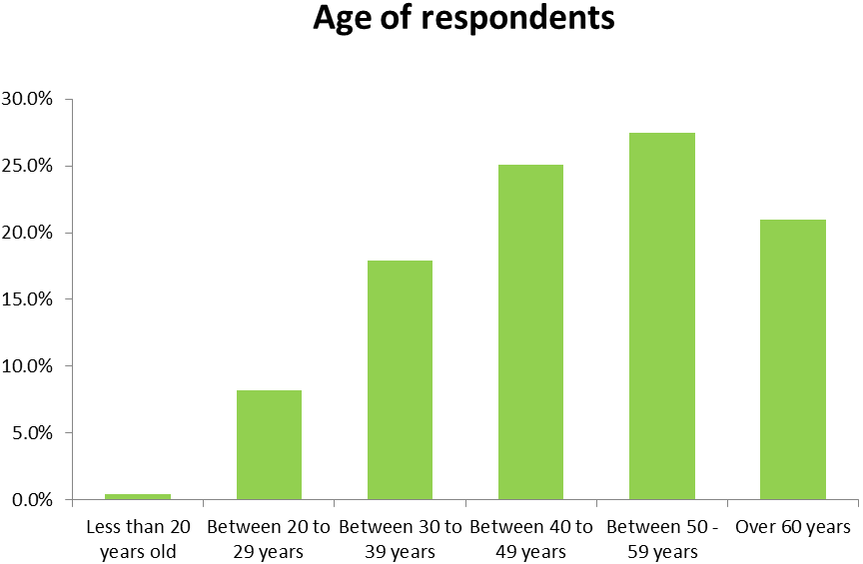
Regional Comparison

39% of responses came from people living in urban areas: Invercargill (33%) and Gore (5%). The remainder of responses were from rural areas. Ultrafast broadband is only available in Invercargill and Gore (note the rollout of UBI Stage One was only 50% complete at the time of undertaking this survey). Results from urban residents and rural residents have been compared on many questions due to there being a significant variation in experience.

There was a good geographic spread of responses from across the region:
- 16% of responses came from Gore and Eastern Southland
- 11% of responses came from Te Anau and Fiordland
- 10% of responses came from Winton and Central Southland
- 10% of response came from Riverton and Western Southland
- 9% of responses came from Northern Southland
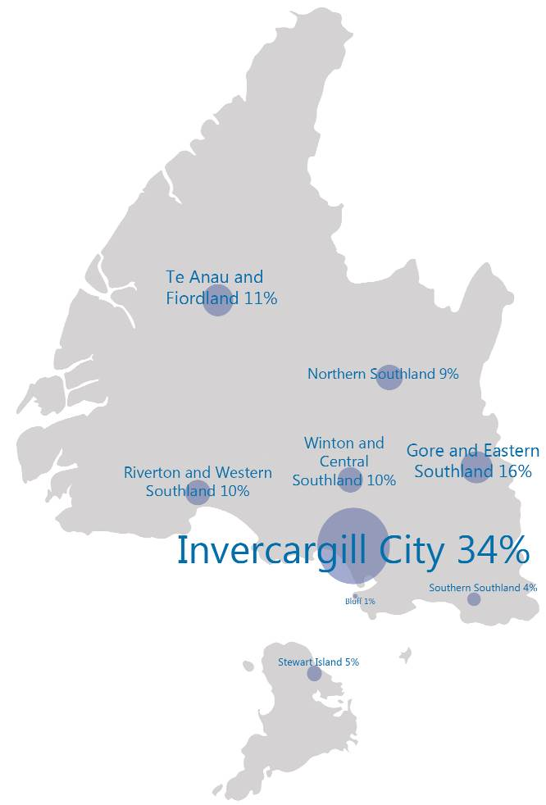
- 5% of responses came from Stewart Island
- 4% of responses came from Southern Southland (The Catlins)
- 1% of responses came from Bluff.

Survey respondents who believe that the quality of their internet or cellphone service is having a significant impact on their lives provided their locations, which are mapped below. Some clusters can be observed but it is notable that dissatisfaction is widespread.
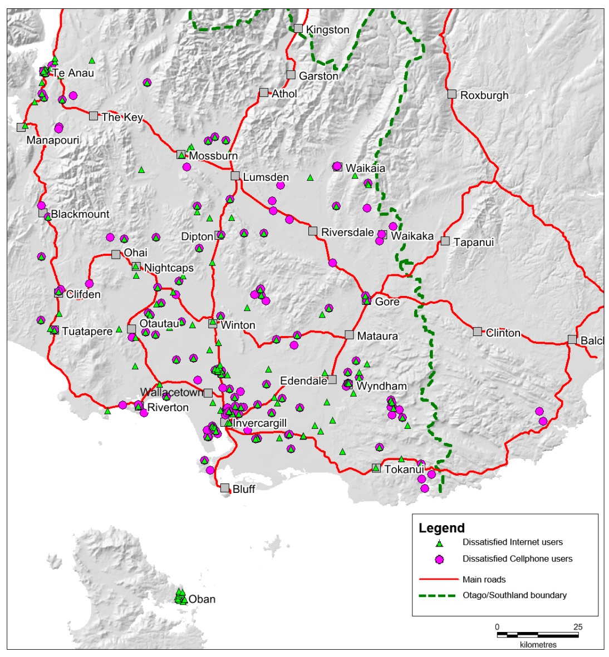

11%
Te Anau & Fiordland
9%
Northern Southland
10%
Riverton & Western Southland
34%
Invercargill
1%
Bluff
10%
Winton & Central Southland
16%
Gore & Eastern Southland
4%
Southern Southland
5%
Stewart Island

Employment

6% of respondents were not in employment. 70% of these were retired, with small numbers of stay at home parents, students and unemployed people responding.

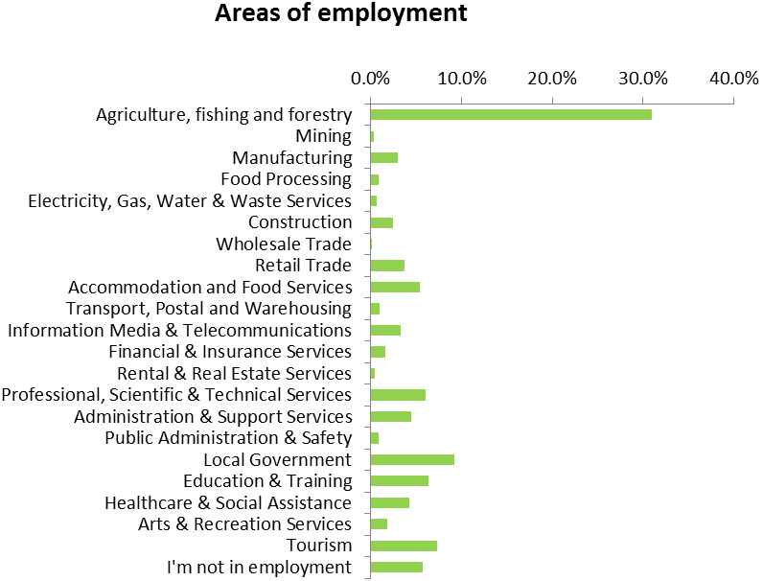
Almost a third (31%) of responses, were from people working Agriculture, Fishing or Forestry. The next largest represented sectors were Tourism and Accommodation and Food Services combined (13%), Local Government and Services (9%), Education and Training (6%) and Professional, Scientific and Technical Services (6%).
Analysis has been undertaken on the responses given by the two largest employment sectors: Agriculture, Fishing and Forestry and Tourism. Details are given where results are substantive.
People working in the agricultural sector were more likely to live in Eastern, Western, Central and Northern Southland and less likely to live in Invercargill. 22% lived in Eastern Southland.
People working in Tourism and Accommodation and Food Services were more likely to live in Te Anau and Fiordland (42.5%), Invercargill (21%), Stewart Island (16%) and Southern Southland (6%).
Mobile phone usage
Less than 1% of respondents have no mobile phones. 54% of households have two mobile phones; 18% have over four.
75% of people use Spark, 35% use Vodafone, 16% use 2 Degrees. A handful use Skinny or other providers.1% have no cellphones as they have no coverage. (Note: these figures add up to more than 100% because some households use more than one network.)
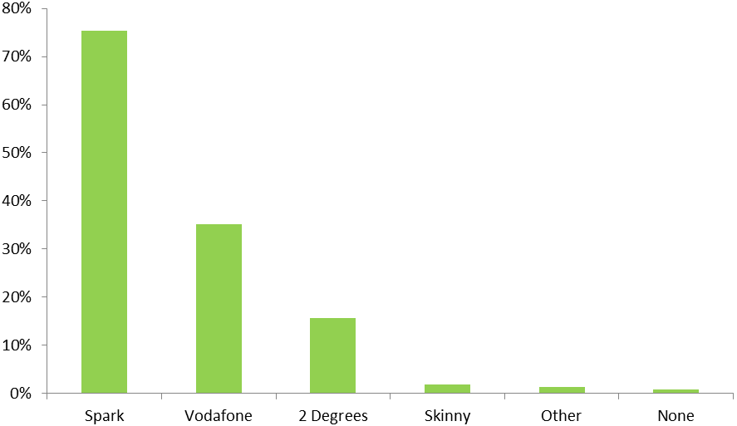

“I feel mobile phone coverage would be of huge benefit to rural people as with that comes access to data which as devices become more capable they are valuable business tools. In this day and age a working mobile phone should not be a pipedream!”

“It seems that each upgrade Spark/Telecom has made to the cell phone coverage that our reception has got worse. Our internet is far more reliable.”

94% use cellphones for voice calls and 96% for SMS text messages. 75% use their phone to access the internet and 60% use apps. 14% use their phone for remote monitoring or control.
Agricultural sector respondents are more likely to use their mobile phone for remote control (17%). Tourism workers were also more likely to use their phones for this purpose: 19%.
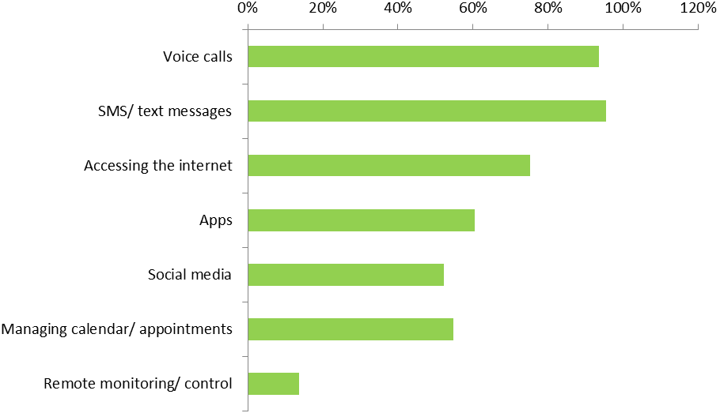
55% of people can use their mobile phone in their home. 8% cannot use their phone at all and 33% only in some locations on their property. 4% can only use one network at their house.
Less than half (48%) of people in rural areas can use their mobile phone in their home, compared to 73% of people in urban areas. 20% of urban dwellers can only use their phone in some locations, compared to 36% of rural people.

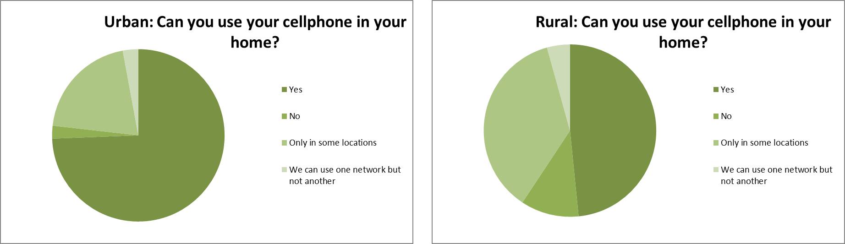
“We live less than 5 mins drive from city centre and we can’t even get proper cellphone coverage.”

Only 34% of people working in the agricultural sector can use their mobile phone at home – the same percentage can use their phone at work. A further 49% can only use their phone in some locations.
In comparison, the tourism sector respondents have similar responses to urban respondents: 74% can use their phones at home and 70% at work.
58% of people can use their phone at their workplace. 6% cannot use their phone at work and 27% can only use it in some locations at work.
There is a very similar picture for people in rural and urban areas when we ask about their ability to use their mobile phone at work.
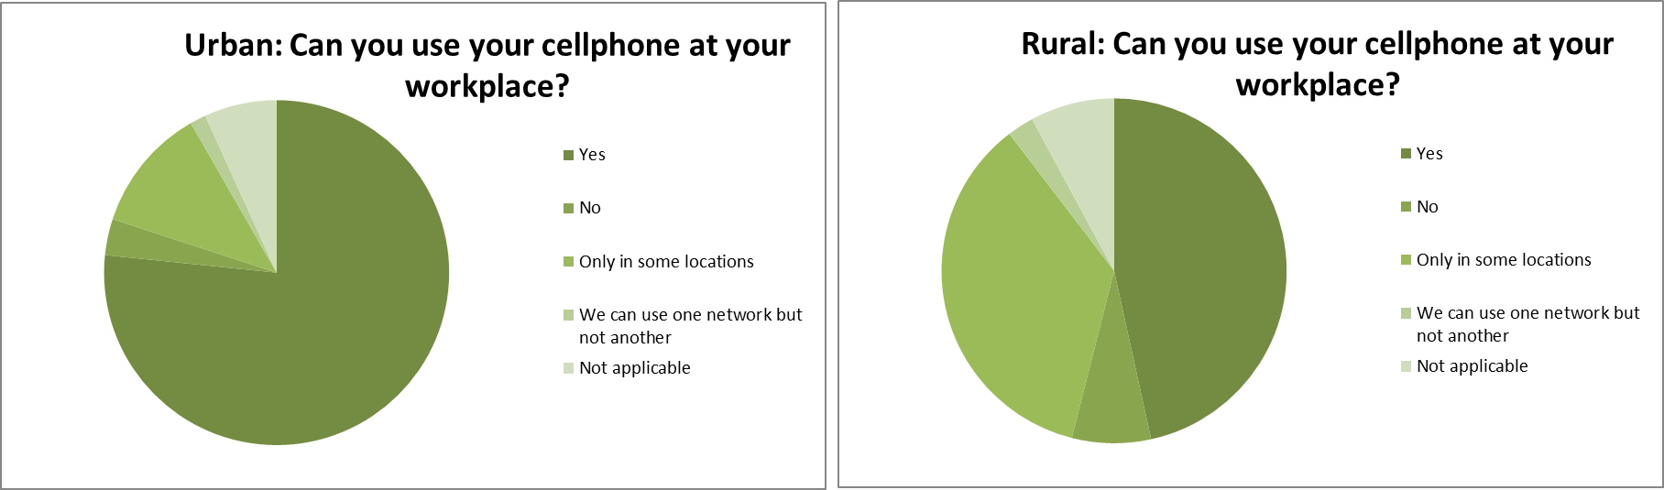
36% of people believe their cellphone service has improved in the last five years. Fewer have seen improvements more recently (21% believe their service is better than it was two years ago, 13% better than 12 months ago). Most say that they have seen no change in their service. 13% think that their service now is worse than it was five years ago.
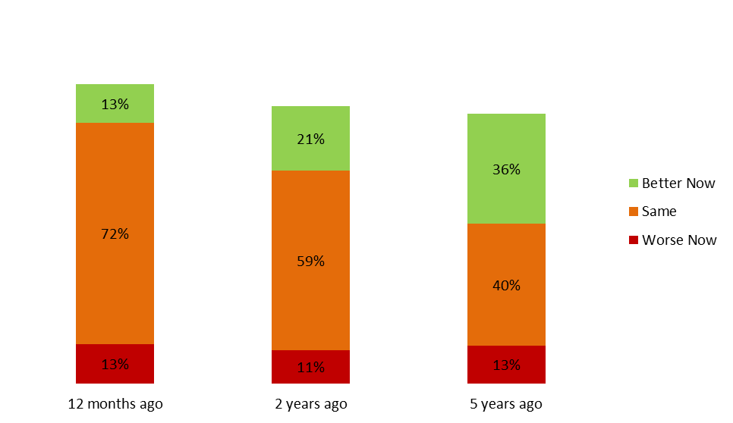
The impact of poor cellphone service
46% of people say that they regularly experience problems with their cellphone service which impacts on their lives. A further 22% experience occasional problems.
47% of rural people report that they or their family members regularly experience problems with their mobile which significantly impact on their lives. In comparison, 39% of urban users say the same.
54% of agricultural sector workers report regular problems which impact on their lives. Only 36% of tourism sector workers report the same.
40% of people are having such significant issues with their cellphone service that they provided their address to have their location mapped.
174 people from rural areas (53%) provided their address as they believe they are having significant issues compared to 60 people in urban areas (28%).

“Having good service would be helpful if only for the safety aspect as I am a single parent with my young son and we are quite isolated 6ks down a gravel road.”
“We only love 25 minutes from Invercargill but our cellphone reception is shocking and is a real concern for the safety of our staff. There are some pockets of coverage on the farm but not at our house or at our sheds, so communication is a real problem. There has to be a solution.”
“I have been disgusted that there has been such a push for broadband when development hasn’t been improved for many cellphones, with many areas of no coverage. So many dead areas – Flora Rd, Mill Rd and many more. It isn’t a fair go that texts are not moving more quickly. The delays are not only at night. This needs to improve dramatically.”
“I think the service we get in southland is cr*p! I purchased a new smart phone, was then rung by a (spark rep), they asked how my new phone was going. I said service in southland was very bad in rural areas. He said, I quote: you chose to live there. Made my blood boil!”

Internet access
97% of people have internet access at home.
Of the 3% of people who do not have internet, expense is the most common reason. Other reasons included that internet was not available in their area or that they did not see the benefit.
82% have broadband services, either through the phone line or through wireless. (Note: there may be some confusion amongst respondents as to how their broadband is delivered which may mean wireless rates are overestimated in this survey.)
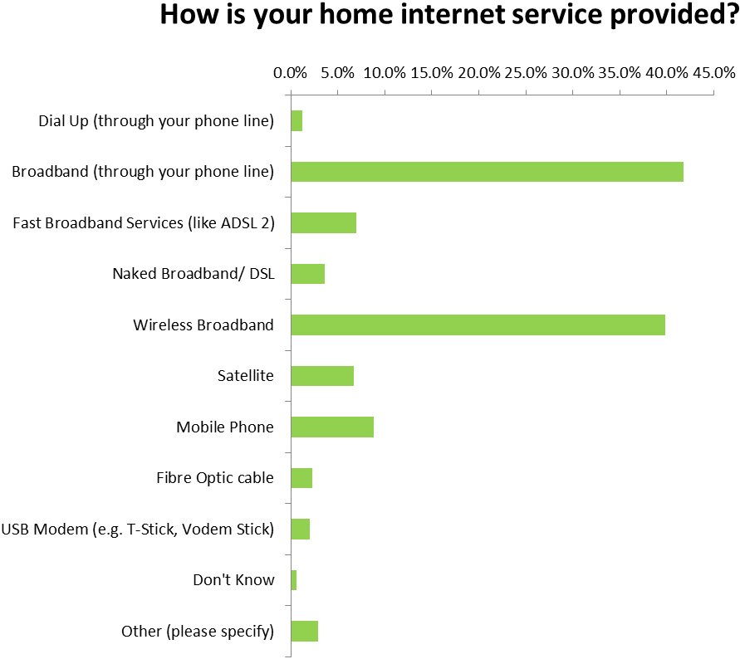
Spark Digital provides internet to 44% of households. Vodafone is the next largest provider (22%), followed by Woosh Wireless (14%) and Farmside (9%).
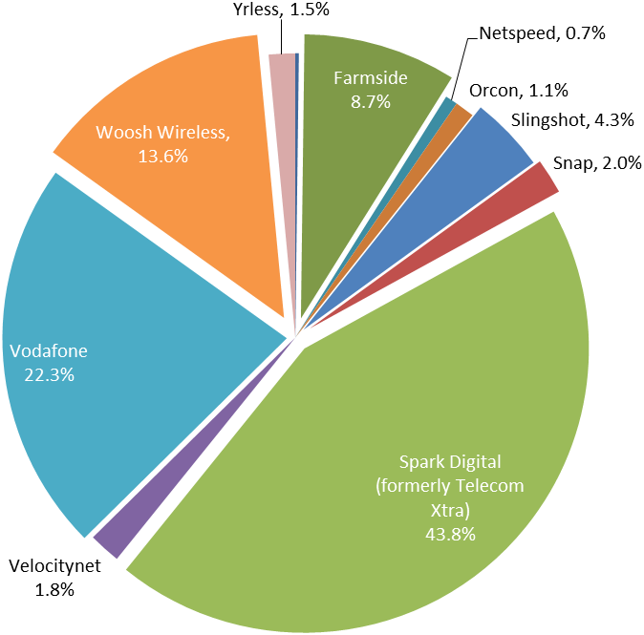
As expected, rural customers were more likely to receive their internet through wireless (44% compared to 31%) and satellite (11% compared to 0%). They are also slightly more likely to use mobile and USB modems. None use fibre optic broadband as it is not available.
Agricultural workers were even more likely to use wireless (53%) and satellite (19%).
Tourism sector workers are more likely than average to use mobile phones or UBS modem (13%); 47% use broadband through the phone line; 32% use wireless, 13% fast broadband and 4% satellite.
The most commonly used providers in rural areas are Spark Digital (39%), Woosh Wireless (19%), Vodafone (18%) and Farmside (15%). In urban areas the most popular providers are Spark Digital (48%), Vodafone (27%), Woosh Wireless (8%) and Slingshot (7%).
34% of agricultural workers use Woosh Wireless, 25% use Spark Digital, 24% use Farmside and 9% use Vodafone.
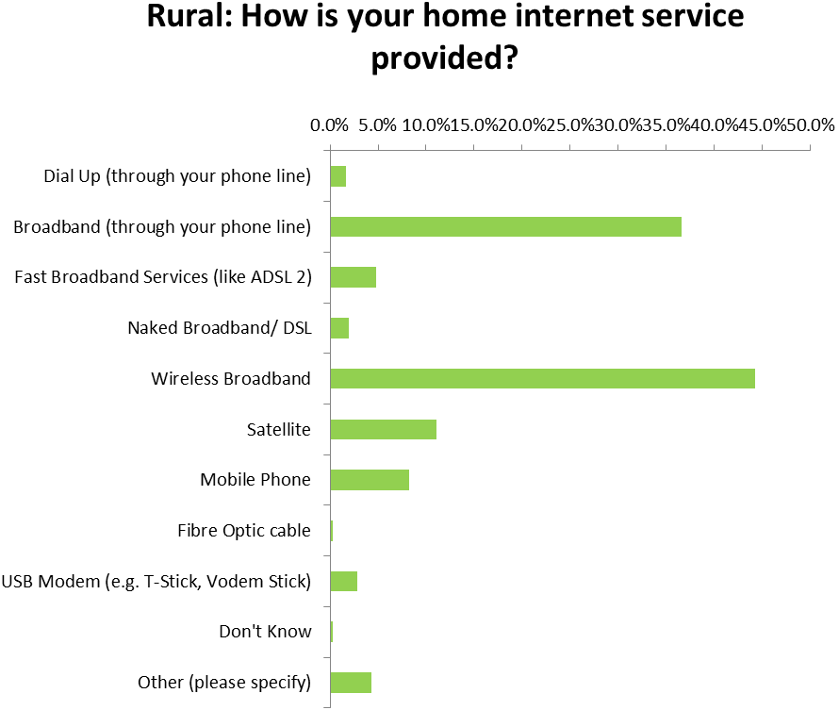
Over a third (36%) are paying more than $90 a month for their internet service.

“The Customer service from our internet provider is terrible, but the hassle to change providers make us unlikely to change. In talking to others this seems to be a common theme.”
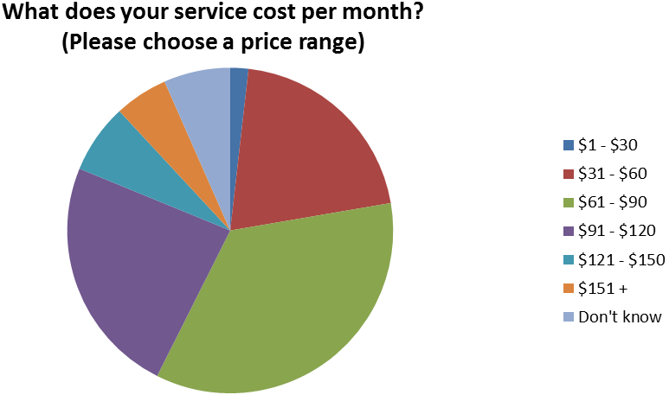
People in urban areas pay on average $10 less a month ($72 compared to $82) than those in the country. However, it should be noted that this is an approximation. 32 (9%) of people in rural areas pay over $151 and it could be that their bill (particularly for satellite customers) is significantly higher than this. No-one in the city reporting paying the highest band costs.
“Our concerns are the lack of options available. We have a 24GB plan that we pay $380+ for! We don’t actually feel that we are getting a good deal compared to what those in town and other places pay. I am rather passionate about the internet options and have spent many hours looking into alternatives and there are just none!”

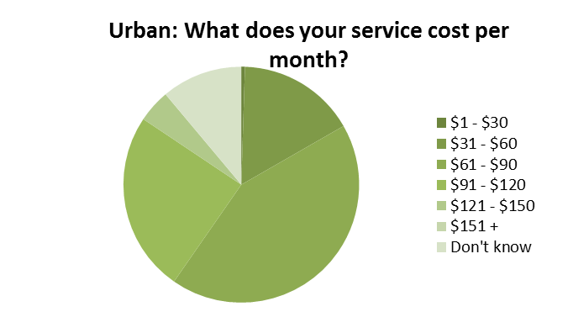

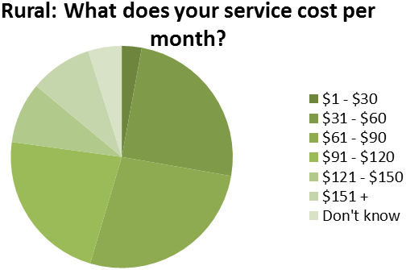

“It is extremely frustrating only having the choice of two ISP providers, namely Woosh or Farmside, with limited services offered by Spark. Because of this I feel as a rural customer I am being penalised for living where I do. Lack of cell phone coverage in this age of modern technology is most frustrating.”

“When we transferred over to spark from our satellite provider we were promised better (still relatively slow compared to elsewhere) speeds, which would have been helpful. But our speed now is absolutely atrocious.”

Using the Internet

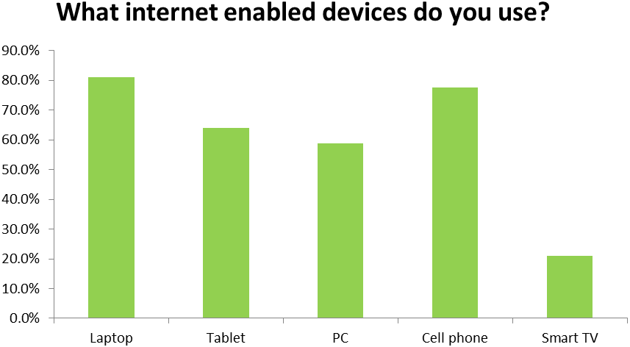

Use of devices was very similar amongst rural and urban users. The only significant variation was in the use of PC, which was 10% more used in the country than the city.

91% of tourism sector respondents use laptops and 79% use cellphones.

“We realise we live in the country, but this is 2015. Our mobile phone service is non-existent and the broadband is the worst we have ever experienced.”
“We are being left behind by the rest of the world which is moving to cloud based services that are clumsy/slow/inoperable on slow connections.”
“We are unable to access the internet at home. Dial-Up is sooo slow that we have stopped this service. We tether our cellphones to our laptop but it sucks up a lot of data so we can’t use it for our children’s education programmes, streaming, downloading or even a few hours surfing the net. I would love to have the ability to work from home but it is currently impossible.”
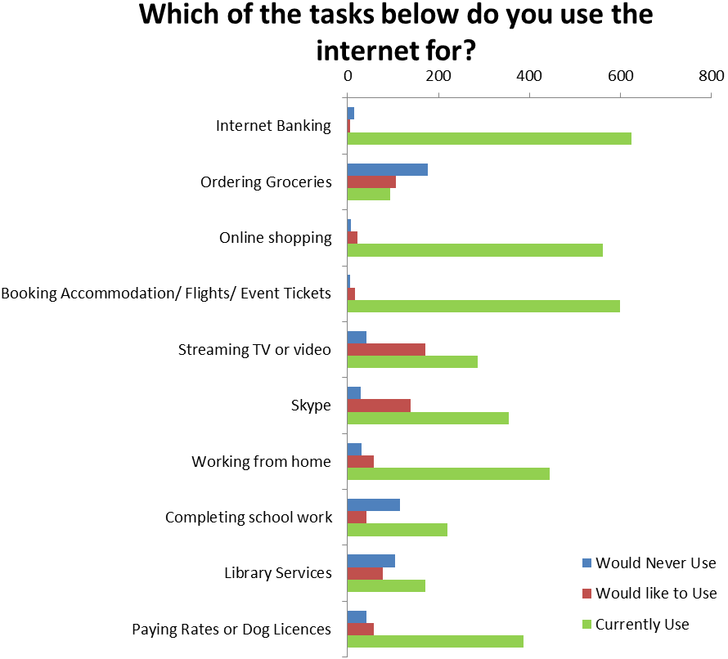
Internet banking, booking accommodation, flights or event tickets and online shopping are the most common activities carried out online.
Streaming TV, Skype and ordering groceries are the three most common activities which people would to be able to undertake but are unable to.
Patterns of use for key activities online where also similar, although rural uptake of many services including online shopping and completing schoolwork online was marginally higher. The only significant differences were in use of Streaming TV and Skype, where rural rates of user were lower. 40% of rural people would like to Stream TV or videos (urban: 23%) and 32% would like to use Skype (urban: 13%). This indicates that rural people make use of those services which they can access but slower connections are affecting their ability to make full use of the internet.
91% of agricultural workers use the internet for working from home and 63% say their family uses the internet for school work.

Quality of Internet Service
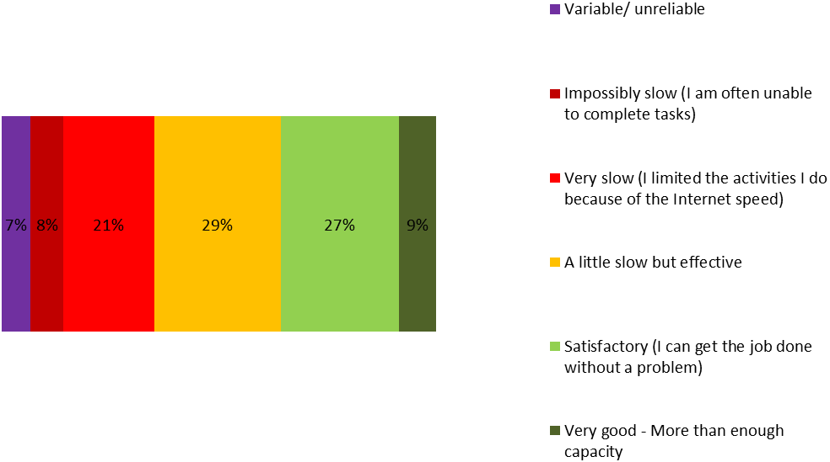
Over a third (36%) of people have an internet service that is slow or unreliable and limits the way they use the internet.
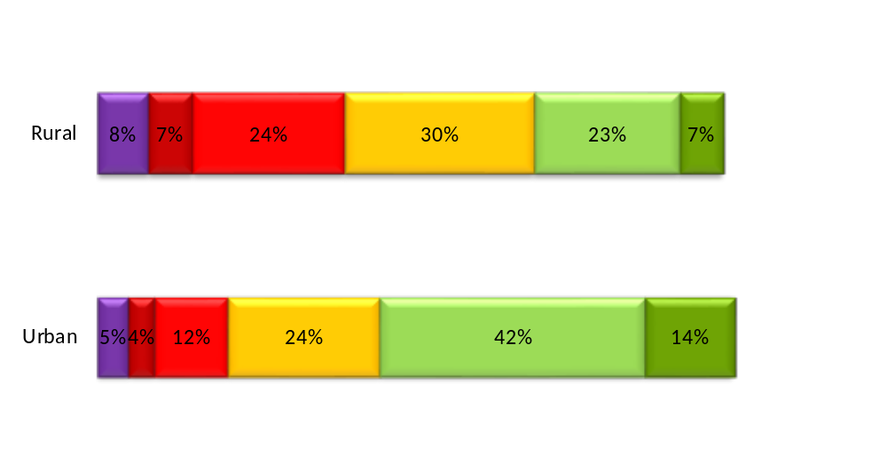
39% of people in rural areas and 21% of people in urban areas believe their service is slow or unreliable.

There is consensus that internet services are better than they used to be five years ago but that there has been little improvement since. Majority of people feel that their internet service is the same as it was 12 months ago (59%) and two years ago (52%). 42% believe that their service is better than it was five years ago.

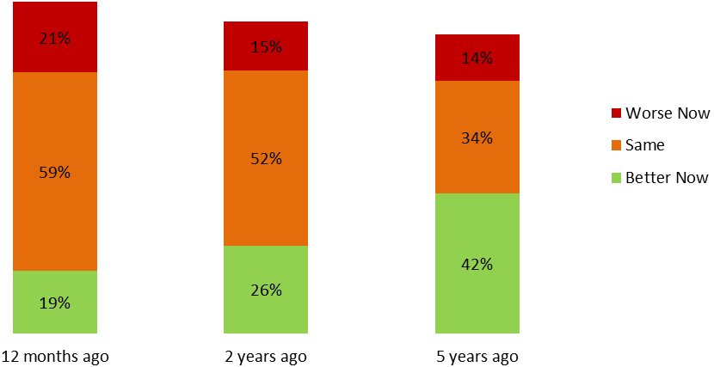

15% of people in rural areas believe that their internet service is better now that it was 12 months ago. However, 20% believe their internet service is worse now, which is 6% higher than the group who felt their internet is worse now than two years ago, suggesting that some people believe their service has worsened in the last year.
In comparison, 28% of people in urban areas believe their internet service is better now than it was 12 months ago. 14% believe it is worse. Again, there appears to be a small group (6%) who believe that the service has worsened in the last year.

“The exchange near our property is overloaded and outdated. It kicks us off the internet regularly, even in the middle of the night. Numerous complaints to multiple providers over the years has not helped – still get charged for a full service when we can barely use it for anything.”

Urban
“As more people have joined the network the slower is has become. A lack of reliability is a big problem particularly when undertaking Skype and using collaboration services…weighty applications are impossible to use.”
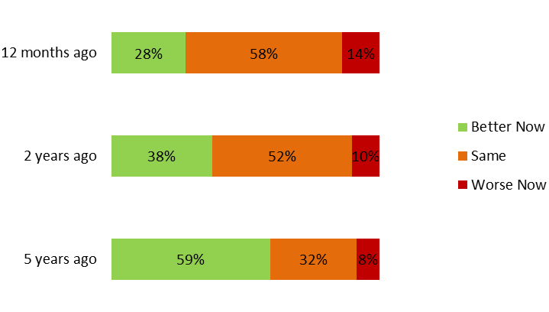

Rural
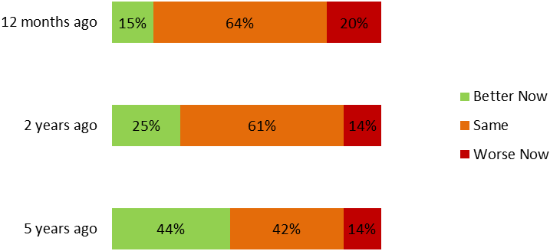

The Ultrafast Broadband Initiative
Ultrafast Broadband is only available within Invercargill City and Gore City. 16% of respondents in this area say that the service is not available to them, so while they may live within city boundaries they may be in areas outside the Ultrafast Broadband coverage.
75% of respondents in urban areas are aware of the Ultrafast Broadband Initiative.
34% know how to access Ultrafast Broadband. 13% already have it; 16% are thinking about it and 5% are not interested in getting it.
45% don’t know how to access Ultrafast Broadband but would like to.
Only 10% of people in urban areas are not interested in getting Ultrafast Broadband.

“They have laid cables. When is available for use? Given we live so close to the city and pay city rates it would be great to have access to reliable internet and cell phone coverage.”

“If schools can get fibre optic, why not everyone?”

The Rural Broadband Initiative
50% of residents in rural areas are aware of the Rural Broadband Initiative (RBI).
59% of agricultural workers are aware of the Rural Broadband Initiative.
Most are unaware of any impact of the initiative on their internet service:
- 25% have noticed no change in their internet service
- 38% don’t know what effect if any it has had
- 34% say that RBI is not available in their area.
Only 4% report any positive effect (2% say the internet is faster; 2% more reliable). The same proportion (4%) say the internet service is actually worse since RBI.
“Yes we pay the same for our internet service as everyone else! but we do not get the quality of service other people round the country receive (I could drive to bank faster than logging on to internet banking on more than regular occasions), considering we live on the main highway into Te Anau and apparently the cable runs straight past our gate! And the Cell reception is a complete JOKE!”
“The main problem with our ADSL internet service is “internet rush hour” – connection speed slows to an unusable crawl between 6pm and 10pm. This problem is getting worse as more people connect to ADSL network in our area. The ADSL infrastructure in the Nightcaps area needs to be upgraded. The Rural Broadband Initiative is all good for those who are going from no connectivity to some connectivity, but as a wireless service it is not cost competitive with ADSL.”

“New towers have helped us (near Fortrose) enormously…much improved from satellite. However, the Waikawa/Curio Bay areas are still without a plan, as far as I know. Their need is urgent.”
“The current providers are not good enough and don’t service the country areas. We in particular are situated in the centre of all the towers and none have strong signal.”
“Very Keen to see ADSL or fibre broadband come through to our business in Wreys Bush. In the meantime we are putting up with Vodafones RBI Internet services which at time are very average, compared to what you can get at home. (Invercargill City).”

Business

374 (56%) respondents own or manage a business.
33% of urban respondents own or manage a business.
68% of rural respondents own or manage a business.
85% of agricultural sector respondents own or manage a business.
70% of tourism sector respondents own or manage a business.
The majority of businesses who responded are small businesses, either sole traders/ partnerships with no staff (36%) or employing between 1 and 5 staff.

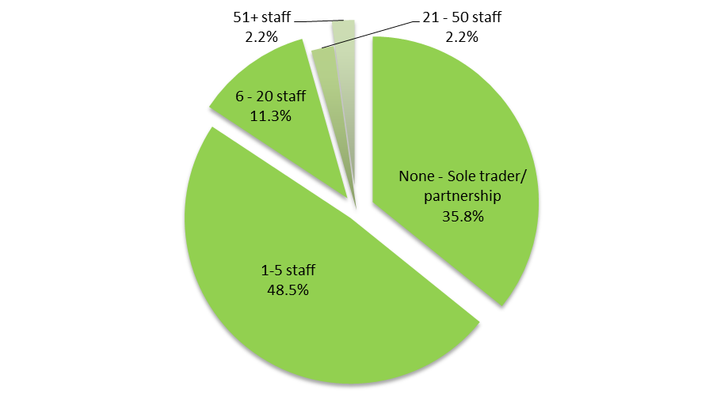

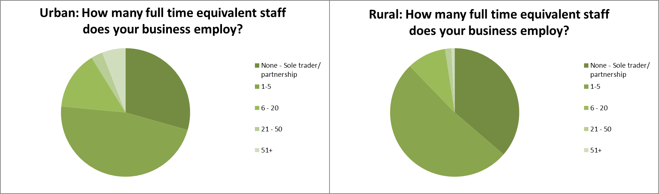

71% of urban businesses and 64% of rural businesses employ at least one staff member. 67% of agricultural businesses are employers. 71% of tourism sector businesses are employers.
24% of rural respondents (27% of agricultural businesses) report that mobile or internet service in their affects their ability to attract staff. Only 16% of tourism sector businesses and 9% of businesses in urban areas experience the same issue.
The majority of businesses use their home internet connection to run their business (82%).
For those businesses which have a dedicated internet connection (18% of the total), 35% are dissatisfied with their internet connection.
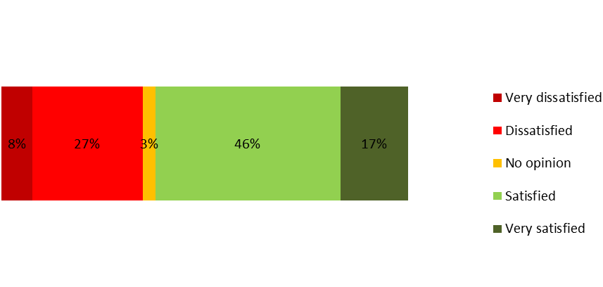
100% of businesses in urban areas reported an internet service fit for purpose. (Note responses to this question were low.) In comparison, 30% of rural businesses say that their internet is not fit for purpose:
- 10% have a very slow connection where staff need to limit activities
- 7% have an impossibly slow connection where they are often unable to perform key activities
- 13% have a variable/unreliable service.
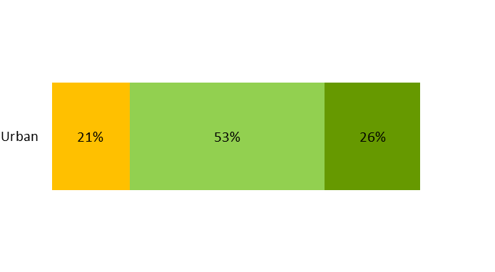
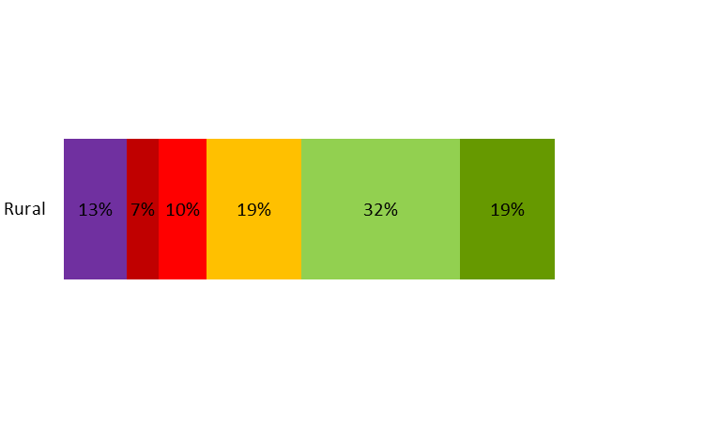
35% of rural business owners and managers are dissatisfied with their internet connection, compared to 16% of those in urban areas.
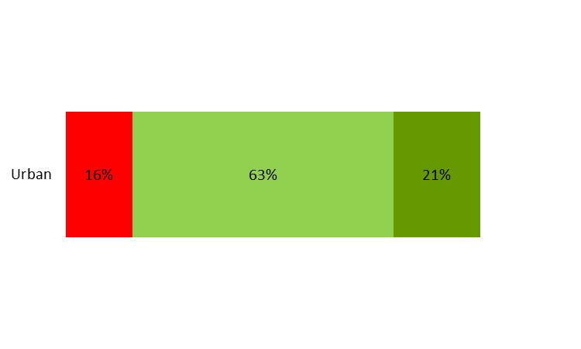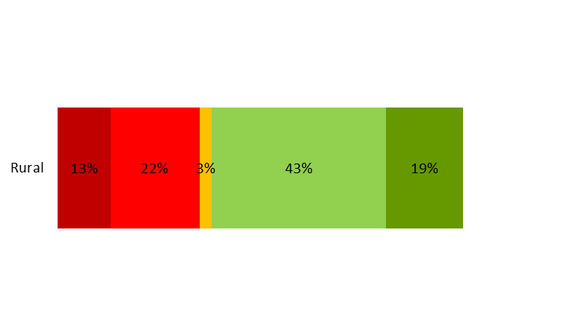
For those businesses which are using their home internet connection to run their business (258 businesses):
- 32% have a satisfactory or very good internet connection
- 31% have a connection which is a little slow but effective
- 32% have a connection which is very or impossibly slow
- 8% have a variable or unreliable connection.
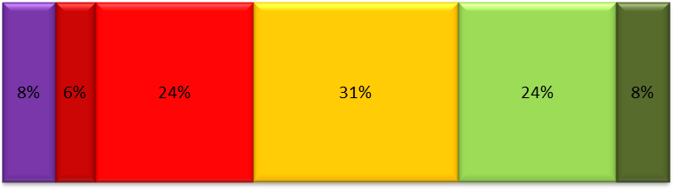
6% of rural business owners that don’t run their business through their home internet service are using Dial Up and 6% are using USB modem sticks. No urban businesses are using these options for internet access. The most commonly used providers are Spark and Vodafone, followed by Snap (urban) and Farmside (rural).

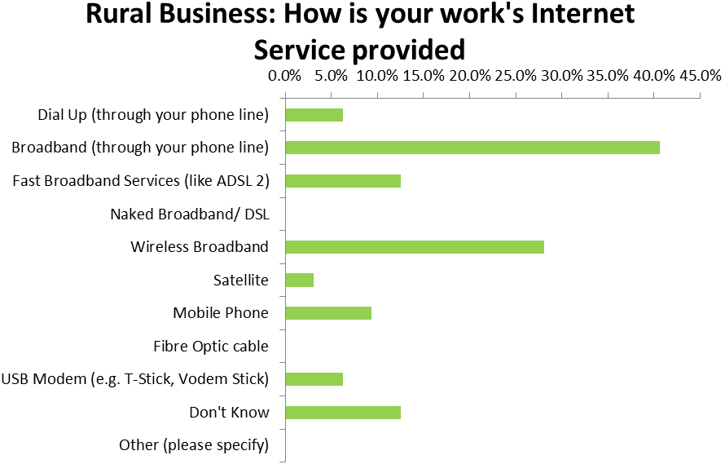
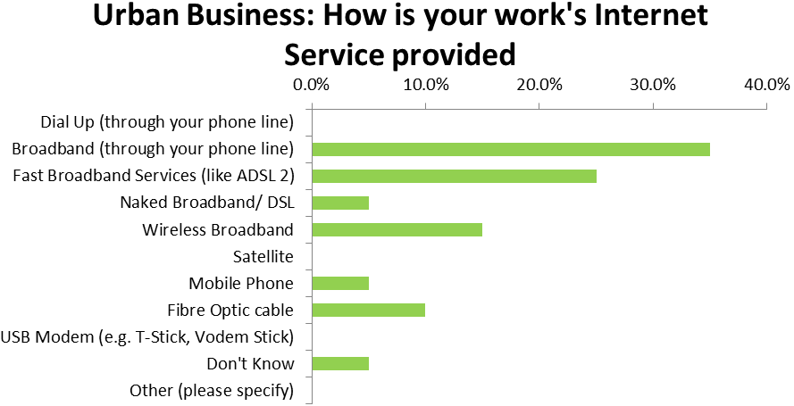
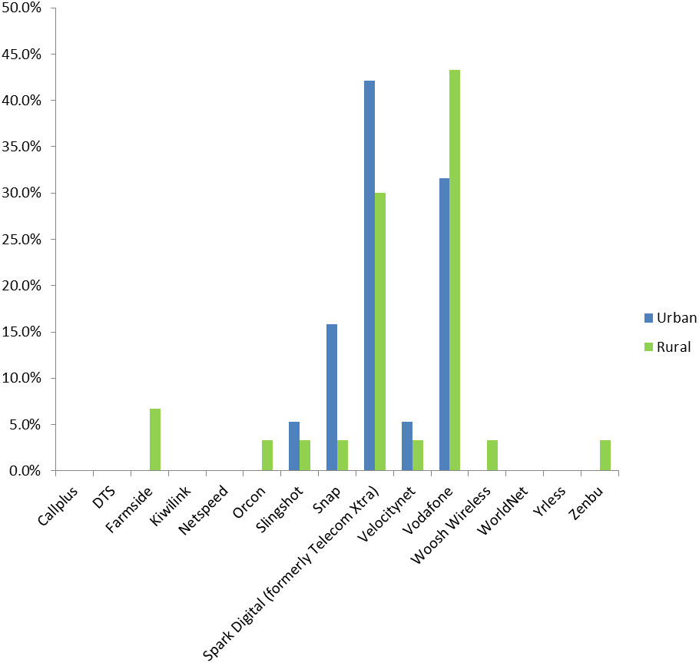

For all businesses, whether they have their own internet connection or share a residential connection, 38% say their internet service does not meet their needs. A further 21% believe their service will not meet their needs within two years. 35% were not able to forecast their future internet needs.
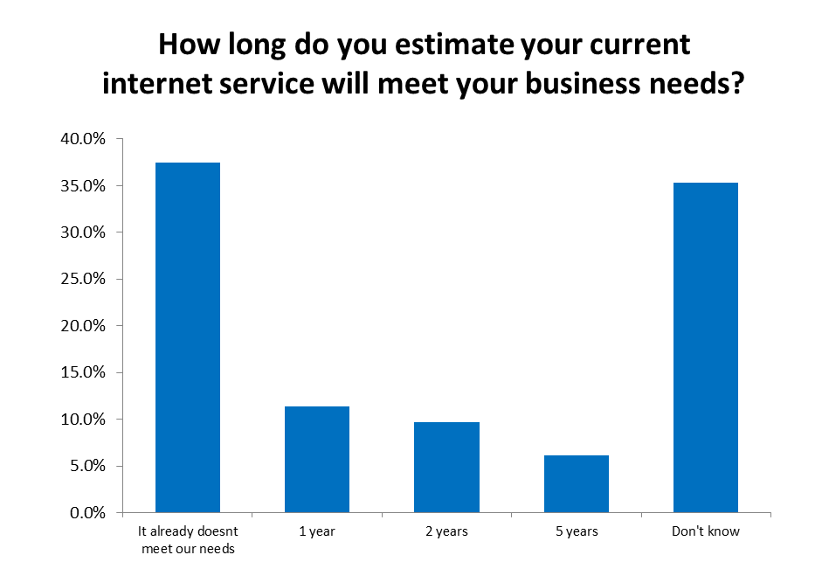
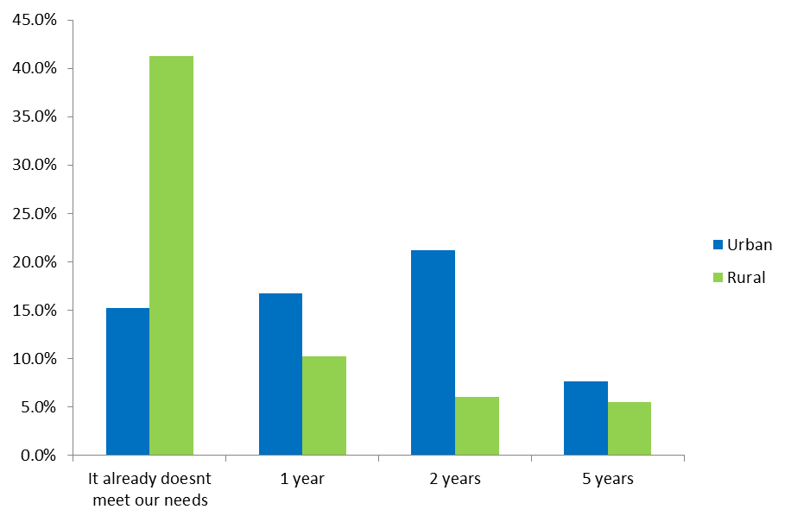
In looking to the future, urban-based businesses were most likely to think that their current internet service would meet their needs for two years. Only 15% reported that the internet already does not meet needs. However, for rural businesses, 41% said that the internet service already didn’t meet their needs. An additional 10% said they anticipated it would continue to meet their needs for another year.
32% of tourism business said that their internet service already did not meet their needs and a further 17% felt that it would no longer meet their needs within the year.
Some businesses found this forecasting difficult – 39% of urban businesses and 37% of rural businesses said they did not know how long the internet service would meet their needs.
The online services most commonly used by businesses were online banking (96%), social media and online marketing (49%), cloud accounting (48%) and Skype or online communication tools (43%).
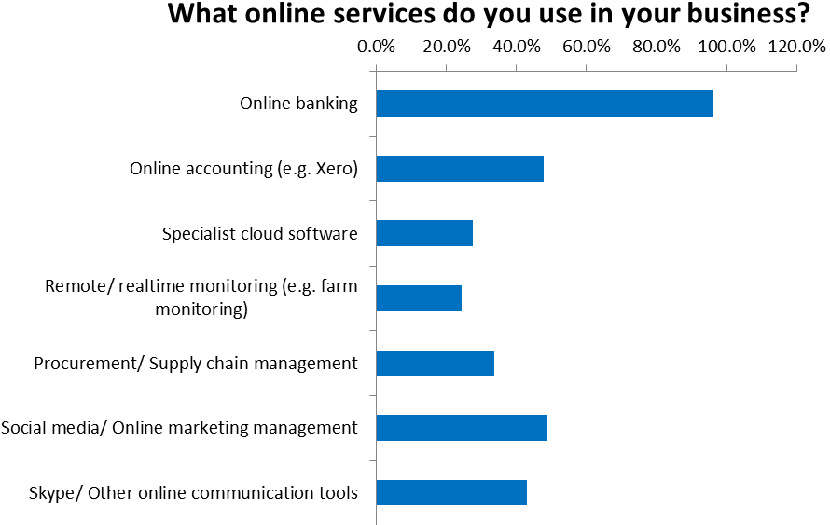
Rural and urban based businesses make very similar use of technology, with the exception of specialist cloud software which is more used by urban businesses, which may be a factor more related to the larger average size of businesses based in urban areas.
Tourism sector businesses were more likely to make use of social media and online marketing (65%) and Skype and other online communication tools (45%).

Tourism Businesses

“Given the popularity of the Catlins with tourists it is essential that cellphone coverage be as accessible as possible. FIT’s are constantly using the internet to search for eateries, accommodation and sightseeing planning.”

“This is a Holiday Park and we provide wifi through IAC (Internet Access Company) but our overseas guests say that is very very slow…”

“I would love to see Free Wifi extended to all of Invercargill. So many other cities & towns have it, and I think we need to in order to attract and encourage business & tourism.”

“Strength of cell signal is so weak inside buildings in Te Anau we constantly lose important sales calls. Also our mobile eftpos machine is unreliable and it’s embarrassing in front of customers. We often have to send them across the street to the nearest ATM machine. Come to New Zealand!!”

Agricultural Businesses

“Yes, we are in a “Black spot” so we are told and broadband etc haven’t come our way, also tried to install internet for employee and unable to proceed due to a/ hedges and b/ area/ and c/ tile roof!!!”

“Have been on the waiting list for upgraded tower at Ram Hill to come online since Sept 2014. Keeps getting delayed. Plan to switch to Vodafone immediately when it comes online. Internet speed is so bad during school holidays and evenings that I have to pay wages through my cell phone on my phone data.”

“Our current service is inadequate and extremely expensive. It makes compliance demands difficult and frustrating. It inhibits our efficiency and productivity. Is also a huge disadvantage for with accidents and health emergencies.”

“Our business is our farm and we should have better coverage for our cellphone and internet and it should be a lot cheaper.”

Only 18% of businesses considered the quality of internet when they chose a location, but an additional 38% said that they should have done. For 43% it was not a relevant factor (many of these made comments that as rural businesses, they have no choice but to operate where the land is).

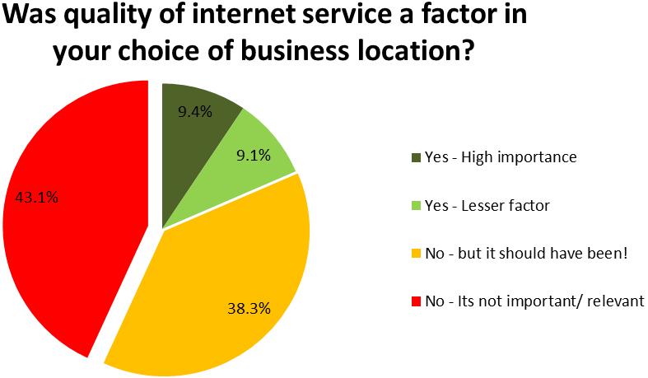

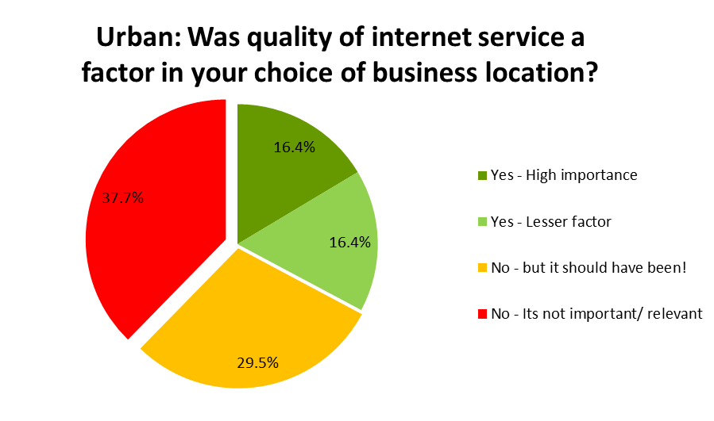

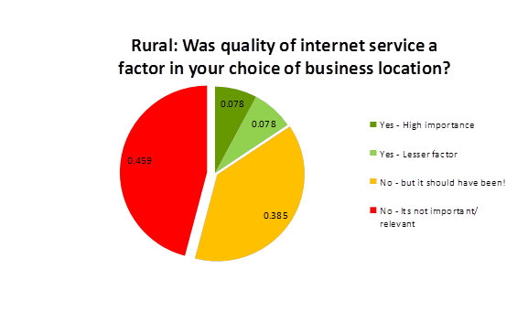

Appendix 8. New Zealand Engineering Excellence Awards 2005
Venture Southland’s Whole of Community Broadband project was a finalist in the IPENZ New Zealand Engineering Excellence Awards in 2005. The entry, without supporting documentation, is reproduced here and highlights the level of commitment and innovation within Venture Southland to achieve workable and useful results in rural telecommunications.

Venture Southland – Whole of Community Broadband Telecommunications Service for Southland

New Zealand Engineering Excellence Awards 2005

Category B: Utilities and Networks

Project outline
Towards the end of the last century farmers in the south began beating a track to the counter of the Southland District Council to complain about their inability to connect to the recently popularised Internet. With no obvious Telecom New Zealand customer point of presence in Southland at the time, the farmers felt that they had nowhere else to go.
Was there a problem? If there was a problem, how big was it? And how could it be solved?
Stephen Canny of Southland District Council and Robin McNeill of McNeill & Associates set to find out. Their findings were published in the seminal report Blazing a Trail to the Information Highway (Annex 1) in September 2001. They found that not only was there a problem, but that it was crippling local industry, schools and farming (See Annex 2a - e). Over a quarter of farmers, for instance, were unable to establish, or maintain a useful dial-up Internet session. Broadband access was limited to parts of Invercargill only.
The most important recommendations contained in the report were for:
- The creation of a consumer trust owned operating company which would request proposals from telecommunication service providers to establish and operate a suitable network to provide ubiquitous, "whole of community" service in the region. The operating company would also aggregate demand for service and facilitate procurement of public good funding if necessary.
- Government departments to purchase telecommunications services at a regional, rather than a national level. It was felt that aggregating demand locally would provide sufficient traffic to attract business cases from competing telecommunications providers and thus stimulate advances in technology and services.
- Meeting the demand from the education sector for broadband service at all schools. By doing this the necessary stimulus for deploying widespread broadband telecommunications throughout the region would also occur.
In April 2002 Venture Southland, assisted by McNeill & Associates, issued an RFP for “Whole of Community Broadband Telecommunications Service for Southland” to this end (see attachment 3).
Influenced by Blazing a Trial to the Information Highway and lobbying by Venture Southland, in June 2002 the Government launched Project PROBE for which the Southland Whole of Community Broadband Service was treated as a pilot (see attachment 4). Project PROBE was included, if a little awkwardly, into the Venture Southland bid evaluation process already under way. The prime difference between Project PROBE and the Venture Southland effort is that Project PROBE is almost entirely focused on providing broadband service to every school, while this is only a part of Venture Southland’s requirements.
A pleasing number of bids were submitted and after comprehensive analysis of the bids, negotiations were concluded in December 2003 to award a contract to Woosh Wireless (see attachment 5). Venture Southland Charitable Trust had meanwhile been established to provide an appropriate entity to represent the people of Southland in the contract. Venture Southland had also procured significant funding for the network from Ministry of Education, New Zealand Trade and Enterprise and Community Trust of Southland to balance the Woosh Wireless contribution. The New Zealand Trade and Enterprise funding was procured through the project being Southland’s Major Regional Initiative (MRI) (see attachment 6).
Under the terms of the contract, Woosh Wireless is required to provide:
- ubiquitous broadband Internet service to 92 to 95% of Southland dwellings
- broadband coverage to every school in Southland
- a uniform pricing and tariff structure, regardless of the subscriber’s location
- toll free ‘on-net’ telephony service throughout Southland
- connection to a local Internet peering exchange.
To ensure that the public-good contribution to the network deployment is targeted at providing ubiquitous service, the contract schedules provide for significant payments to Woosh Wireless for remote rural sites that could not be profitable, ranging through to no payments for urban sites that could be expected to be commercially viable in themselves.
In October 2003 the Prime Minister, Helen Clark, launched the service at Tuatapere, New Zealand’s westernmost town. Service was provided through an iPWireless point to multi-point wireless Node-B located at an existing local site. Since then Woosh Wireless engineers and local contractors have been deploying some twenty wireless sites around Southland. Professional support was provided by Robin McNeill.
At an early stage it was recognised that the mobility and some attributes of the iPWireless equipment were not necessary for certain applications and would not be cost-effective for very small communities. Accordingly, so called extension technology in the form of Trango point to multi-point wireless is being deployed to access small communities and schools.
At the time of preparing this entry, most iPWireless sites have been completed or are nearing completion and coverage is expected to reach 92% of Southland occupied dwellings by late July 2005 (see attachment 7). Subscriber take-up is pleasing, especially considering that because of the uncontrollable site acquisition timetable it has been impossible until now to develop a coherent marketing strategy.
Connection to the Southland Internet Exchange (SIX) is anticipated to be undertaken as soon as the exchange has been completed in July.
The launch of the telephony service is programmed for later this year.

Contribution to the national economy
Southland makes up some 10% of New Zealand’s land mass, its economy accounted for 2.5% of total economic activity in New Zealand in the year to March 2004 and has a population of 92,000 people, 2.3% of New Zealand’s population. Its regional GDP in 2004 was $3.5 billion. Some 19% of the GDP share is derived from agriculture, compared to less than 6% for New Zealand overall. For Southland to continue to prosper, efficiencies in the rural sector are vitally important. The benefits of broadband communications to Southland are discussed at length in Blazing a Trail to the Information Highway, but a single representative example suffices: Fonterra claim that better information to farmers could increase direct farm income by 4%, or $150 million per annum nationally.
Blazing a Trail to the Information Highway was influential in persuading Ministers that the lack of broadband Internet access throughout New Zealand needed to be addressed. This was manifested in the subsequent Project PROBE, which provides broadband access to every school in New Zealand.
The need for broadband in rural communities is especially pressing, to an extent that has been long overlooked by urban planners. The diversity of needs are detailed in attachments 2a to 2e, while a representative range is shown in attachment 10.
A predicted outcome of deploying the Woosh Wireless network is that competition would be excited in an area that would otherwise be ignored. Regardless, Telecom New Zealand has since been energetically rolling out its ADSL network in Southland to the extent that most small towns in Southland now have Telecom New Zealand’s Xtra Jetstream service available without the previously required subsidisation or underwriting. Coverage includes communities that had previously been claimed to be very expensive and difficult to service, such as the town of Oban on Stewart Island. As a result, many Southlanders living in or close to towns now enjoy a choice of affordable Broadband Internet providers and technologies.

Impact on quality of life of relevant communities
Unlike the only other major broadband service in Southland, the Woosh Wireless service is both ubiquitous and, as can be seen from table 1, uniformly priced.
Service | Installation cost, including modem | Monthly (unbundled) rental
Woosh Wireless | $199.00, or $99.00 on contract | $39.95
Telecom New Zealand Xtra Jetstream (Only available in towns) | $198.99 or $0 on contract | $49.95
Telecom New Zealand Xtra Wireless | $1,475.00 | $109.95
Baycity Farmside satellite service | $3,559 - $4,159 | $99.00
Table 1. Residential service tariffs for 256kbps service with a 1GB monthly data cap. Prices include GST.
For most farmers, for whom Telecom New Zealand’s Xtra Wireless service is the only alternative should it be available, the installation cost for a Woosh Wireless connection is $1,376 cheaper. Over a year, Woosh Wireless service is $840.00 cheaper to use than any comparable service where such service is available.
The Woosh Wireless Trango equipment is able to provide telephony and Internet to very remote areas, in a manner first proposed in Blazing a Trail to the Information Highway. Trango equipment is about to be deployed commercially for this purpose using small repeater enclosures on hillsides. Farmers who recently applied for telephone service from Telecom New Zealand in the Lilburn Valley and have been quoted $180,000 to be connected could instead be served at a fraction of this price.
Apart from a few early sites, much of the Woosh Wireless network has only just become operational and at the time of preparing this entry comprehensive coverage has just been achieved. This has made it impossible until now to run a co-ordinated marketing campaign. Nonetheless, Venture Southland receives regular contact from farmers and remote businesses wishing to connect to the service. Many of the farmers have expressed no compunction about felling trees to improve their signal if necessary. There have been anecdotal accounts of excited rural dwellers finding they have service, purchasing a modem and then visiting all their friends in the district with the modem to show it off. Many communities beyond the primary coverage area are requesting service extensions.
There are many examples of new businesses and enterprise opportunities being developed in rural Southland as a result of the project: translation services, horticulture, genetic research, accounting and so on.
Venture Southland staff have given many talks to service clubs and groups throughout Southland, all of whom have expressed a great interest in the project. Examples of public interest can be seen in attachments 8 and 9.
Many new business and community initiatives have been driven by the availability of broadband services, some of which are demonstrated in attachment 10.

Contribution to building the reputation of New Zealand Engineering
The Southland Whole of Community Broadband Network is ground breaking and impacts on future projects in that:
- the project is the first to set out to provide broadband to all schools in a province. In this respect it both predates Project PROBE and can be considered to have influenced Project PROBE’s inception and development; the key recommendations in Blazing a Trail to the Information Highway for using schools as the catalyst for broadband rollout and for a regional, as opposed to national, agreement were adopted.
- it will provide ubiquitous, single priced service to the “whole of community” as far as is practicable in a region that is predominantly rural.
- it is the only telecommunications network designed primarily to address the needs of rural communities; Southland has 92,000 residents located across 10% of New Zealand’s land mass.
- the public-private partnership between Venture Southland- representing three territorial local authorities- and Woosh Wireless is unique in New Zealand.
- it is the first network designed to provide regional toll-free telephony.
- It is the first regional broadband network implicitly designed to peer locally
Stephen Canny is highly respected by the Government’s “Digital Ministers”, government officials and the industry for his vision for “whole of community” telecommunications, e-government and digital communities. He is frequently quoted in industry journals and presented “Whole of Community Broadband Telecommunications and Cross-border e-Commerce” at the APECTEL conference in Bangkok in 2002. It was subsequently endorsed by APEC in Moscow. Mr Canny was invited guest speaker at the Australian Telecommunications Users conference in Canberra, November 2003. His presentation there, “Telecommunications for Enabling Regional Economic Development”, continued this theme.
A key factor in the success of the project has been the strong support by Ministry of Eductation, NZTE, Community Trust of Southland, Southland local body politicians, and in particular Southland District Mayor, Frana Cardno. Their continued support is directly attributable to their confidence in Venture Southland and the key staff involved in the project.

Standing as world best practice engineering
Venture Southland is advised that the network is the World’s first rural carrier grade W-CDMA broadband and telephony network.
From the onset, Venture Southland emphasised that the Woosh Wireless network was not so much about installing the latest, leading edge broadband wireless technology – though this was an important requirement – but establishing, literally, a foundation for future wireless networking. In ten years time the iPWireless equipment currently being installed will be dated, if not obsolete. However, the towers, access roads, site agreements, power lines and equipment enclosures will remain viable well into the foreseeable future. The core network facilities being and already installed are important as much for what they offer the future as they are in providing a badly needed service.
When the network is fully deployed later this year, it will have taken just on two years to provide the level of coverage that the cellular telephone companies in the province have taken decades to achieve. Further, as Woosh Wireless can testify, deploying a network in a rural environment is much more difficult than in an urban area or CBD: obtaining sites is much more difficult due to the few landowners to choose from; environmental concerns expressed under the RMA are more difficult to satisfy; the remoteness of the sites make them difficult to establish and provide power to; weather becomes a major factor in the construction of the sites; and events in the farming season – such as lambing – introduces additional complications.
At the time of preparing this entry, most iPWireless sites have been completed or are nearing completion and coverage is expected to reach 92% of Southland occupied dwellings by late July 2005 (see attachment 7). More importantly, it is the last few percent of the population served that are the most important to reach as they are the most difficult and expensive to provide coverage to, though the most in need of service through their remoteness.

Attachments
1 | Blazing a Trail to the Information Highway (File on CD ROM)..
2a - e | Blazing a Trail to the Information Highway sector reports (Files on CD ROM)
3 | RFP: Whole of Community Broadband Coverage for Southland (File on CD ROM).
4 | Clipping: Broadband backing, The Southland Times 8/5/03
5 | Clipping: e-farming 2003
6 | Letter from Her Worship, Mayor Frano Cardno
7 | Coverage map of Southland for iPWireless
8 | Clipping: Girl pushes broadband case, The Southland Times 20/8/03
9 | Letter from Neil Robertson, Brunel Peaks Station
10 | Tuatapere launch video (RealPlayer file on CD ROM)

Download at www.venturesouthland.co.nz/Portals/0/Documents/R1168979%20Southland%20Digital%20Strategy.pdf
As raised later in this proposal, the existing copper underground network that provides individual telephone service also has a 50 year design life. In places this lifetime has been reached and within the next 15 years all Southland underground cabling will have reached its design life.
These maps need to be interpreted with great care. The Woosh Wireless so-called “Trango” sites assume a flat earth and so do not accurately portray coverage in the hilly country they are in. This is mitigated by the GPS sourced CPE locations, which are accurately marked. The Chorus DSL coverage maps would appear to contain significant anomalies when viewed closely and much of the rural coverage claimed is open farmland- one VDSL cabinet at Gorge Hill between Mossburn and Te Anau would appear to serve just one customer. Anecdotal evidence from installers suggests that of Vodafone’s claimed RBI coverage, actual locations that can get coverage is around 90%. Neither Vodafone nor Spark’s cellular or RBI coverage is shown here as it is not accurate enough to provide any useful insight.
ttp://vcmike.wordpress.com/2006/08/18/metcalfe-social-networks/
W H Melody in "Telecom reform: Principles, Policies and Regulatory Practices, ed. W H Melody, Tech. Univ. of Denmark, 1997.
Venture Southland is a combined committee of the Southland and Gore District Councils and the Invercargill City Council formed under Section 114(s) of the Local Government Act 1974. It is the combined tourism, economic and community development agency for Southland. Further information is available at www.southlandnz.com.
Stephen Canny, NZCE, Group Manager, Venture Southland, formerly with Southland District Council.
Robin McNeill, BA, BE(Hons.)(Elect.), MIEEE, MIPENZ, Enterprise Project Manager, Venture Southland, and Principal of McNeill & Associates, see www.robinmcneill.co.nz.
Provincial Broadband Extension, otherwise known as Project PROBE was developed jointly by the Ministry of Education and the Ministry of Economic Development with the primary goal of providing broadband service to all schools in New Zealand.
Woosh Wireless was trading as Walker Wireless at the time.
Source: MED, New Zealand's Regional Economic Performance, Final Report, September 2004.
Sourced from the Telecom New Zealand website at the date of preparing this entry.
ADSL (Jetstream) service in Southland has a range of around 4km in urban areas and 6.8km in rural areas from a DSLAM (Digital Subscriber Line Access Multiplex). In Southland DSLAMs are mostly located in exchange buildings.
Farmside service is 256kbps down/ 128kbps up with a data cap of 600MB per month.
Prices sourced from Woosh Wireless and Telecom New Zealand websites and telephone sales response from Baycity at the date of preparing this entry.

