

**Thursday 10 August 2017**

ASB Arena

81 Truman Lane,

Tauranga

3pm-4.30pm

(Coffee and tea available from 2.45pm)

Join us for a conversation about the future of health in the western Bay of Plenty

Hear **Dr Lance O'Sullivan** on the future of health service planning and delivery

and i-MOKO – using technology in our thinking about the future of health and wellbeing in our communities.

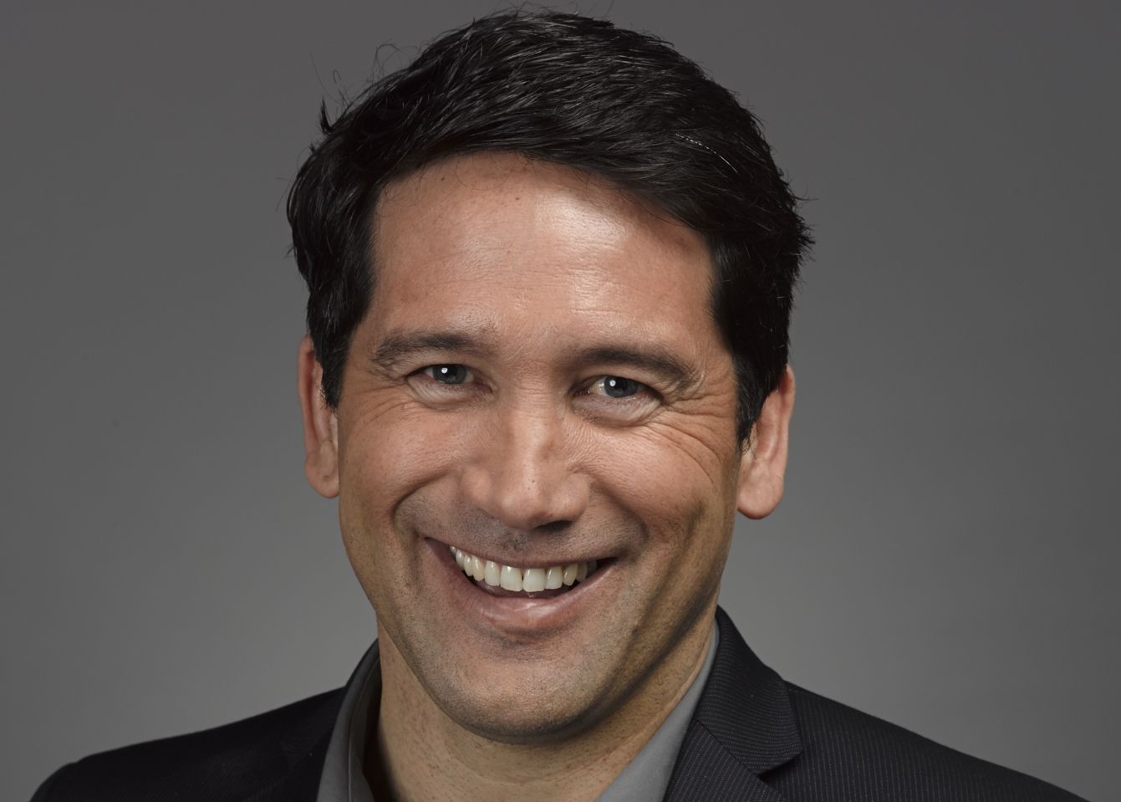

Listen, question and then hear the discussion with a local panel.

Register [here](http://www.tauranga.org.nz/events-calendar/#id=1195&cid=502&wid=1201)

***Supported by:***



Stay up to date with SmartGrowth news and developments by subscribing to our [newsletter](http://www.smartgrowthbop.org.nz/about-smartgrowth/newsletters/)